**Retail Store Microservices Project Documentation**

**GitHub-URL: https://github.com/Bhargavkulla/AWS_CAPSTONE_FINAL_PROJECT.git**

**1) Project Overview**

This project implements a Retail Store Microservices Application with high availability, monitoring, CI/CD automation, and cross-region disaster recovery. It uses Amazon EKS, CloudFormation, Terraform, CodePipeline, CodeBuild, SonarQube, CloudWatch, and Prometheus-Grafana for a complete DevOps lifecycle.

**2) Infrastructure Setup**

**Networking (VPC and Subnets)**

* VPC Creation

Enabled DNS support (necessary for EKS and RDS)

* Subnets

2 Public Subnets

2 Private Subnets

* Internet Gateway

Created and attached to the VPC

* NAT Gateway

Created in Public Subnet 1 using an Elastic IP

* Route Tables

Public Route Table: Associated with public subnets and route to IGW

Private Route Table: Associated with private subnets and route via NAT Gateway

**EKS Cluster Setup**

* Created Amazon EKS Cluster for container orchestration.

**Database Layer**

* Amazon RDS (MySQL) for catalog service
* Amazon DynamoDB for cart service
* DB Subnet Group created for RDS

**3) CI/CD Pipelines**

**Region 1 – us-east-1 (CloudFormation)**

* Infrastructure provisioned using **CloudFormation StackSets**
* Deployment pipeline created using **AWS CodePipeline**
* **Elastic Container Registry (ECR)** created for image storage
* **CodeBuild** used for build and deployment stages
* Verified deployment using:

**aws eks update-kubeconfig --region us-east-1 --name ecommerce-cluster**

**Region 2 – us-west-1 (Terraform)**

* Infrastructure built with **Terraform** via **CodeBuild**
* Code source maintained in **AWS CodeCommit**
* Application deployed with **CodePipeline**
* Verified deployment using:

**aws eks update-kubeconfig --region us-west-1 --name ecommerce-cluster**

**4) Application Monitoring**

**Amazon CloudWatch**

* Log Collection: Using Fluent Bit DaemonSet to push logs to CloudWatch Logs
* Metrics Visualization: Container Insights enabled for CPU, memory, and pod availability
* Alarms Setup:
  + High CPU Usage (>80%)
  + Pod restart detection (>1 restart in 5 mins)
  + High Memory Usage (>30%)
* Alerting:
  + SNS Topic eks-alerts created
  + Email subscriptions configured
  + Verified alert delivery via email

**5) Code Quality Analysis**

* Integrated **SonarQube** with CI pipeline
* Ensured:
  + No bugs or security issues
  + Passed Quality Gates
  + No code duplication

**6) Domain and Routing (Route 53)**

* Purchased domain: **bhargavkulla.com**
* Configured **Failover Routing Policy** with Route 53
* **Health Checks**:
  + Primary Endpoint (us-east-1)
  + Secondary Endpoint (us-west-1)
* Automatic DNS failover from primary to secondary region upon health check failure

**7) Monitoring Stack (Prometheus & Grafana)**

* **Deployed in Monitoring Namespace**
  + Prometheus (kube-prometheus)
  + Grafana
  + Kube-state-metrics
  + Prometheus-node-exporter
  + AlertManager
* **Grafana Dashboards**: Configured to monitor Kubernetes and application performance

**8) CI/CD Event Triggers and Notifications**

**Pipeline Failure Notifications**

* **SNS** topic created
* **Email subscription** added
* **Lambda Function** configured to send alerts
* **EventBridge Rule** triggered on CodePipeline Pipeline Execution Failure event

**9)Final Verifications**

* All Kubernetes pods and services verified to be running
* Frontend load balancer accessed using the domain
* Alert testing completed successfully
* Verified successful failover and DNS resolution using Route 53

**Architecture Diagram**

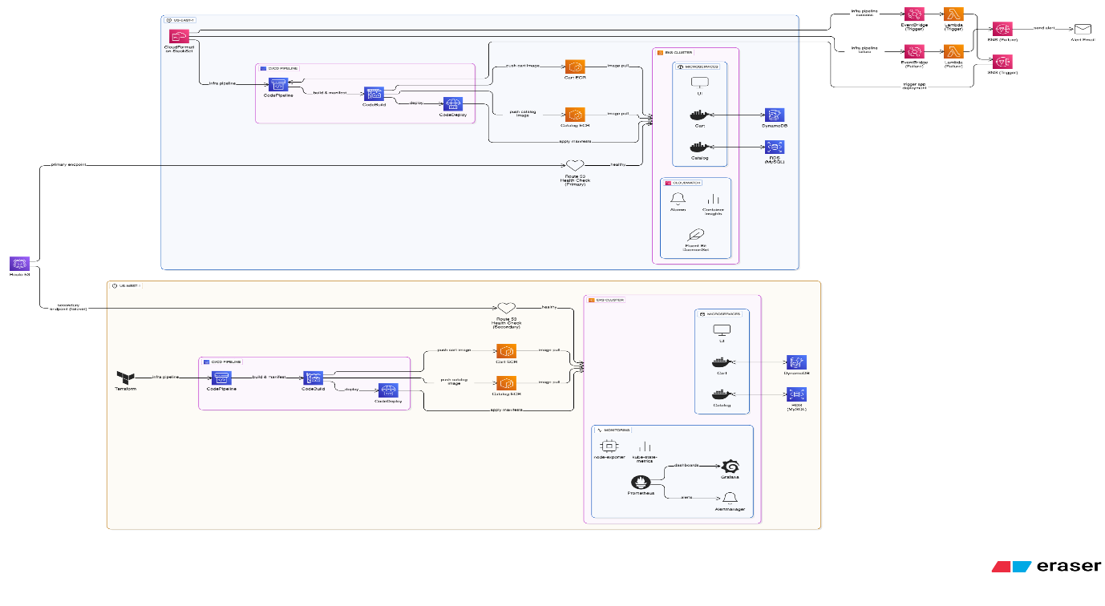

**PIPELINES (Screenshots)**

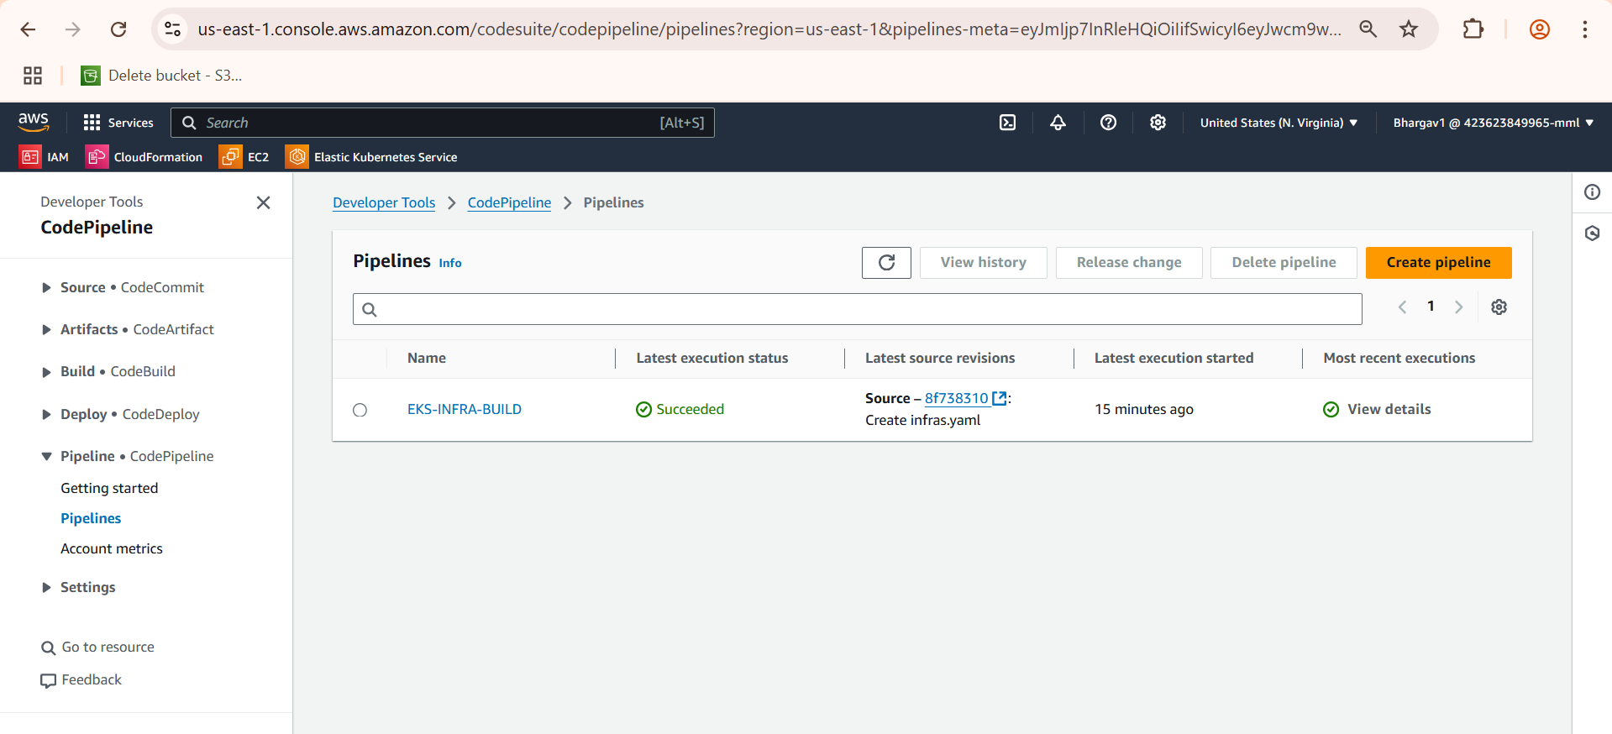

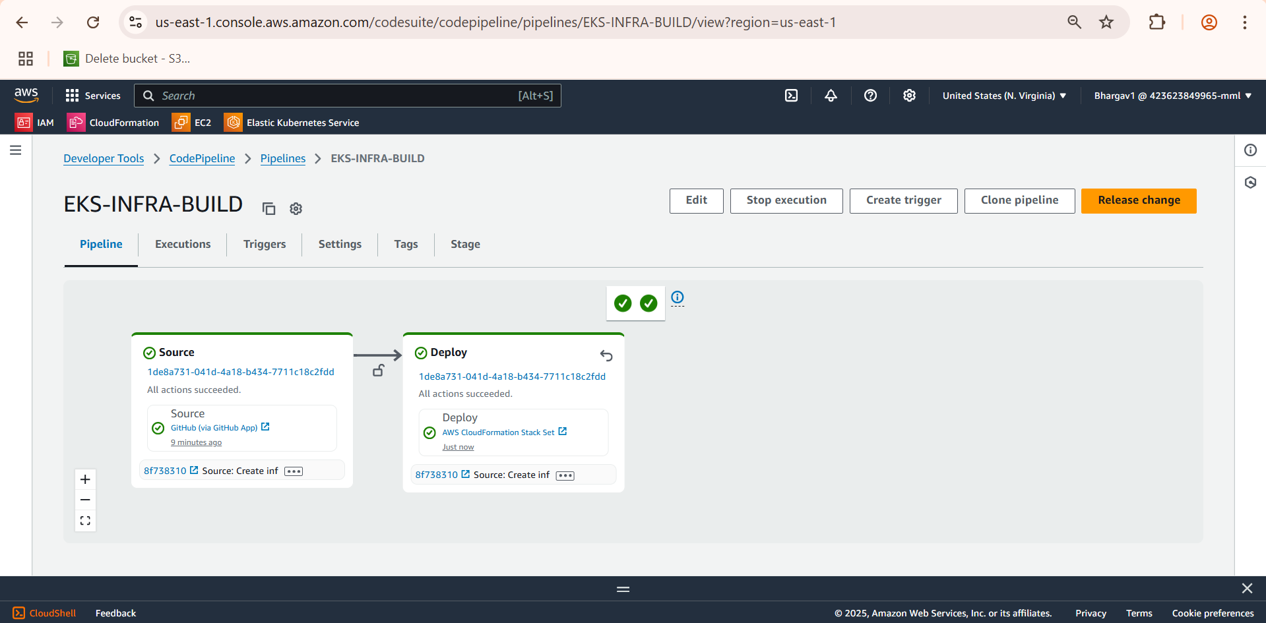

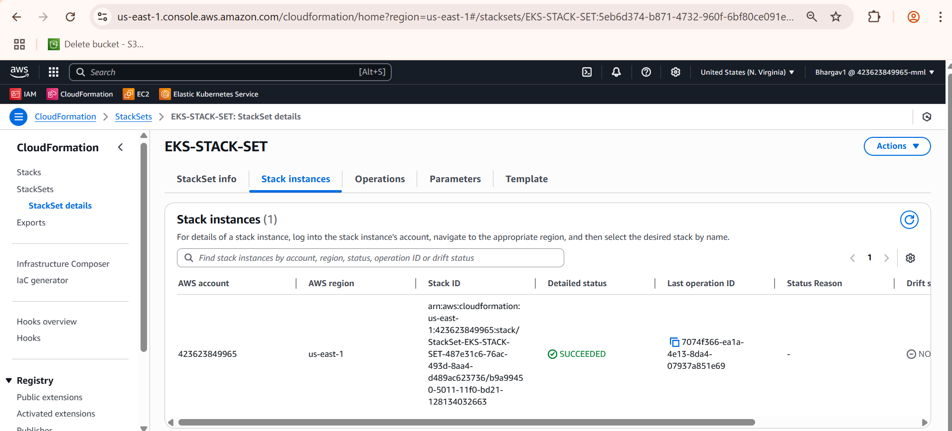

**ECR (Elastic Container Registry)**

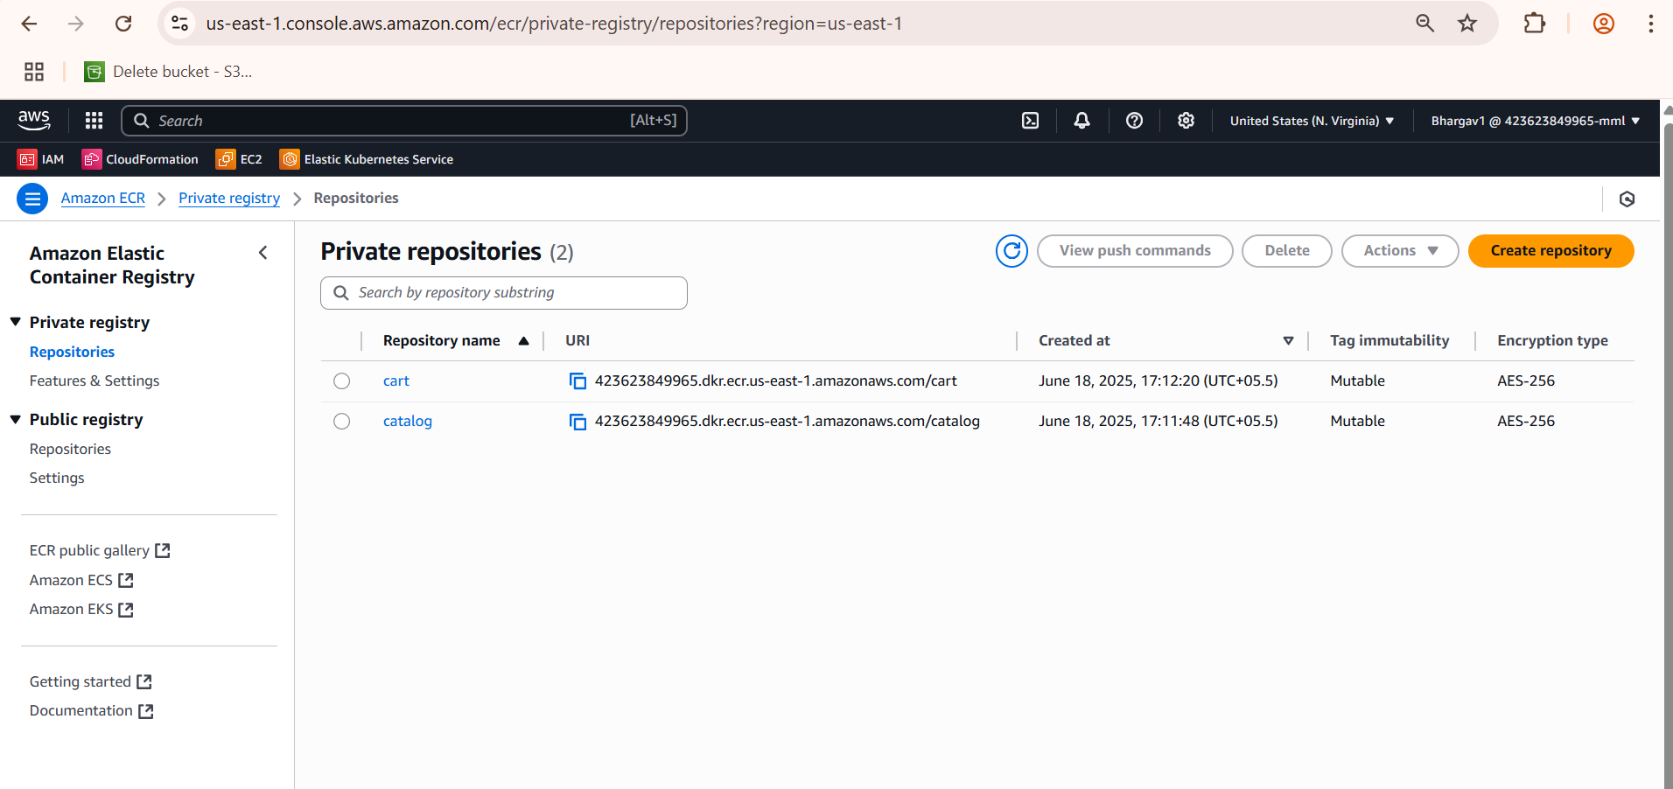

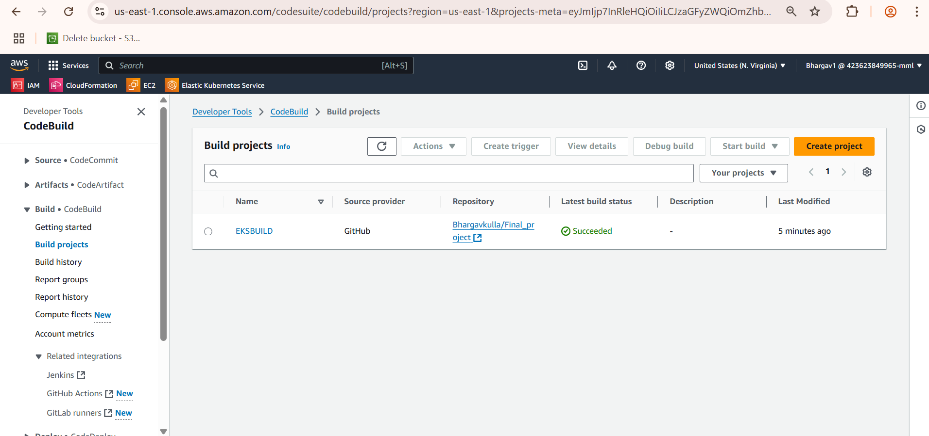

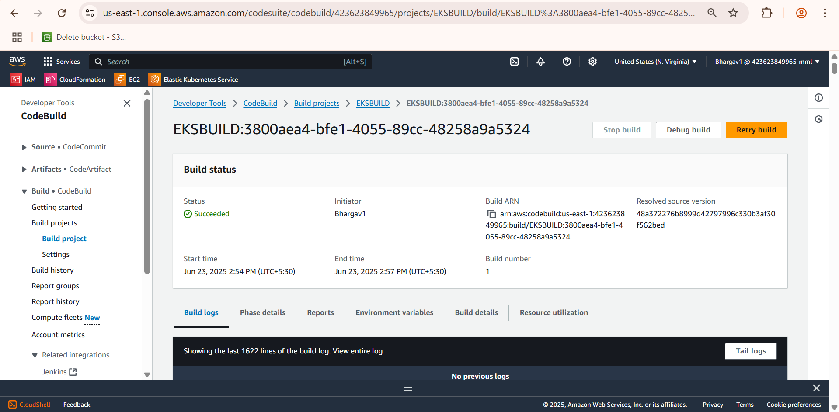

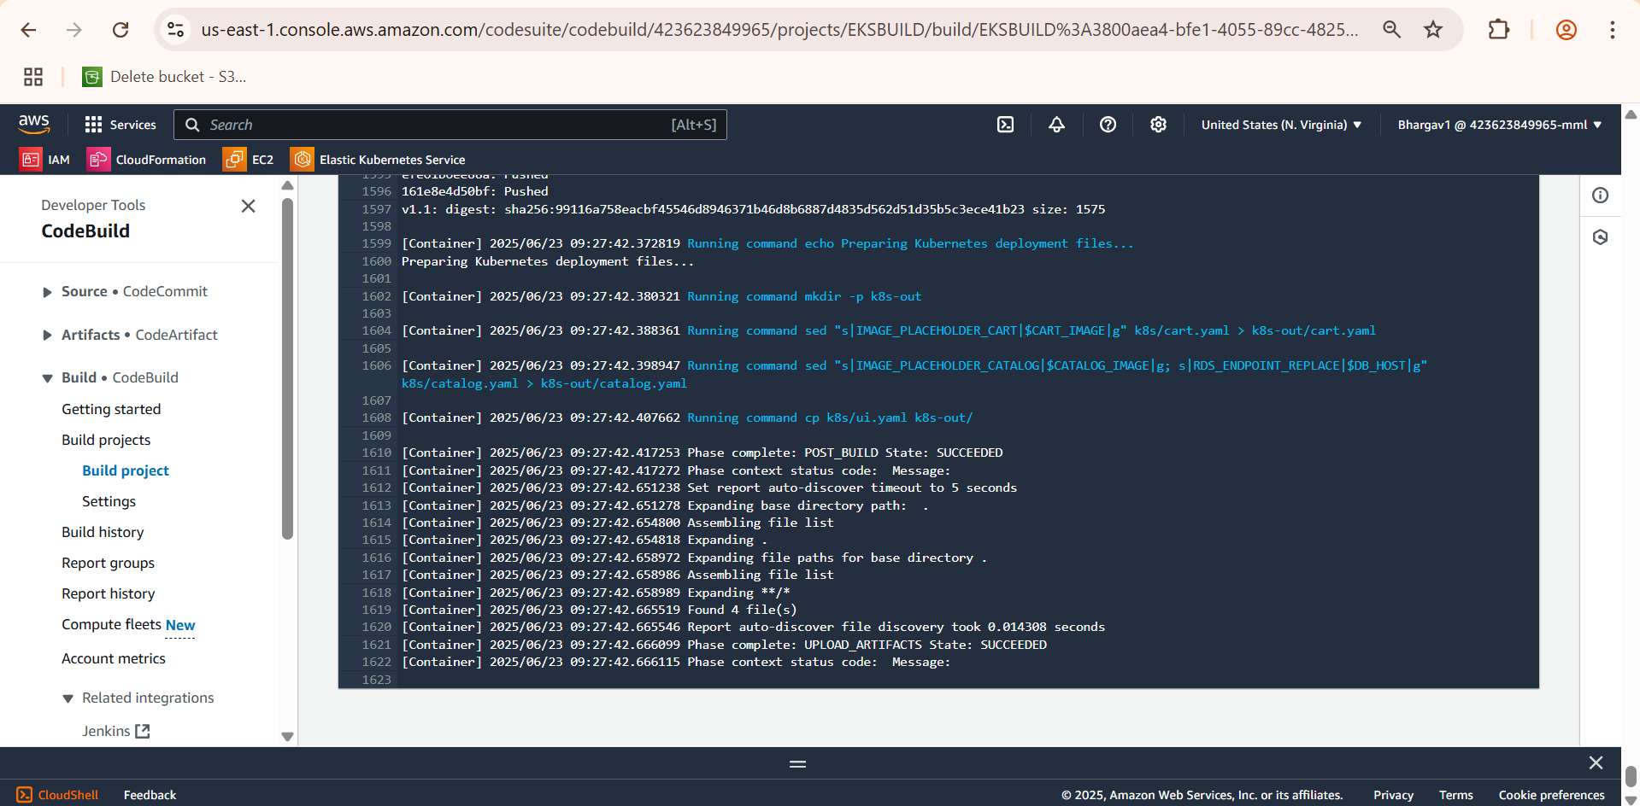

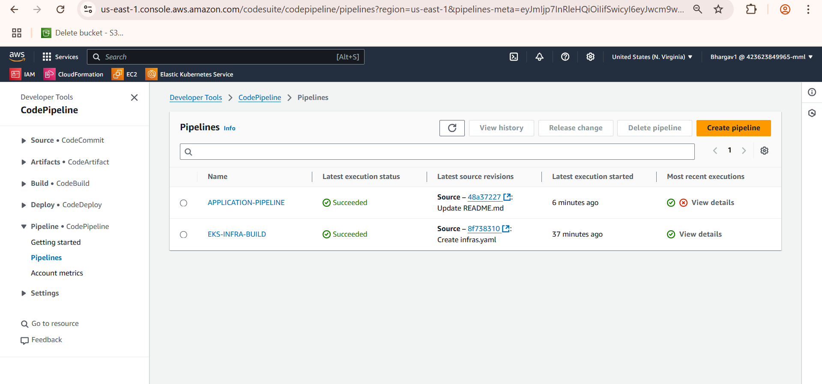

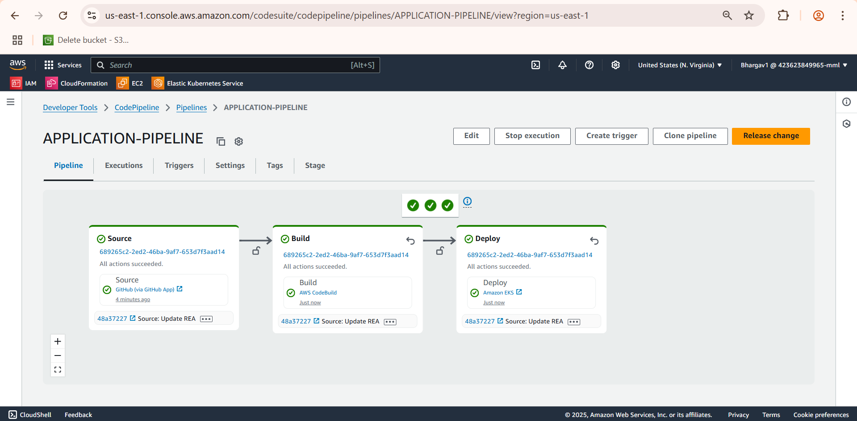

**Amazon CloudWatch**

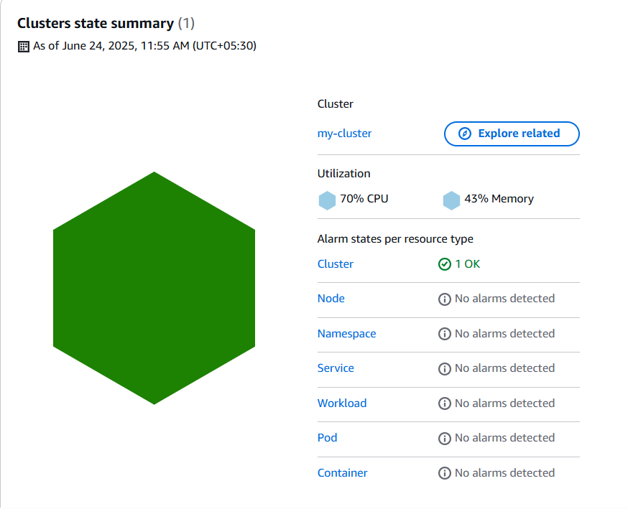

Fluent Bit is deployed as a DaemonSet to collect logs from all nodes and send them to CloudWatch Logs.

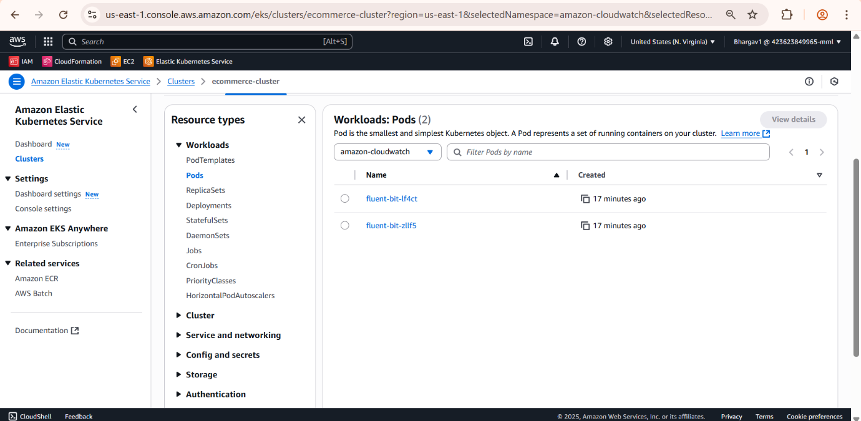Logs are automatically grouped by namespace:

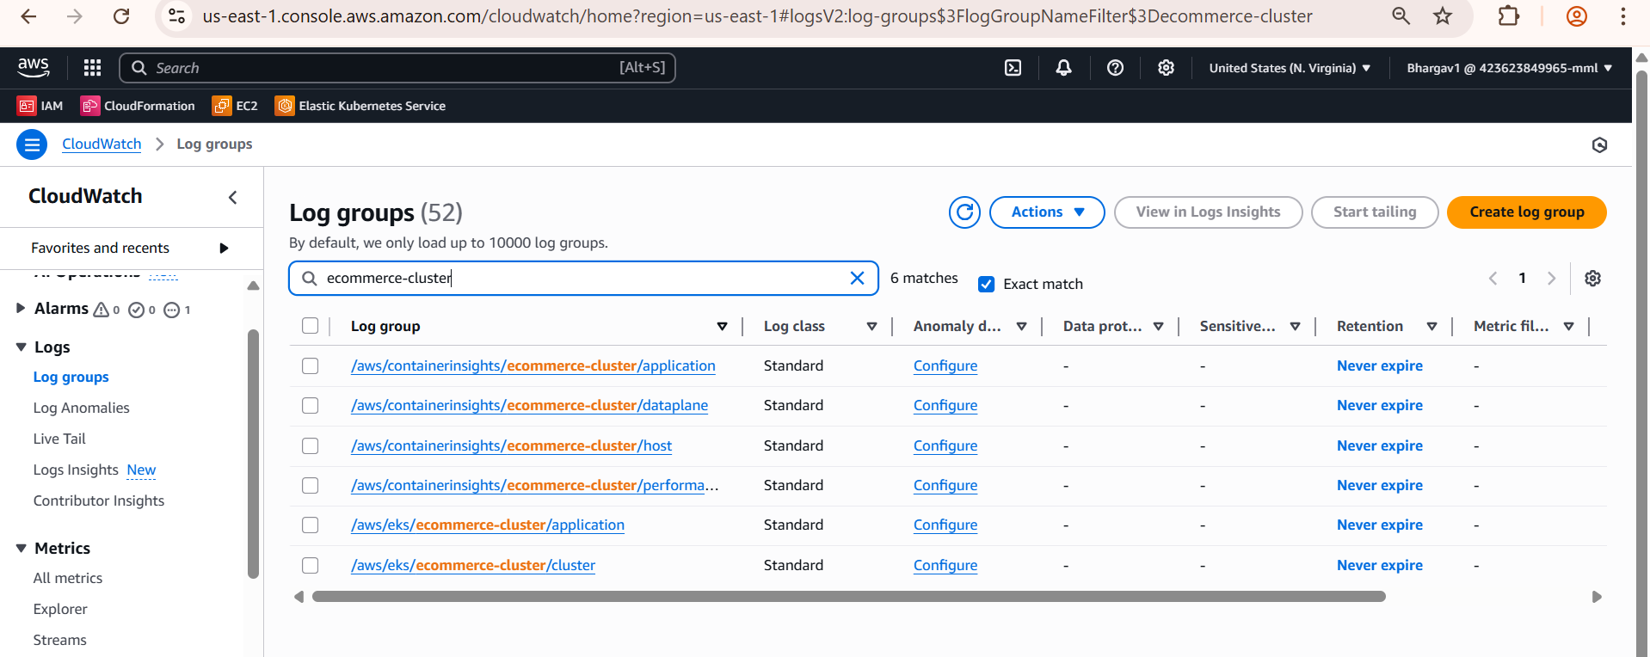

Metrics like CPU, memory, and pod availability are visualized using Container Insights.

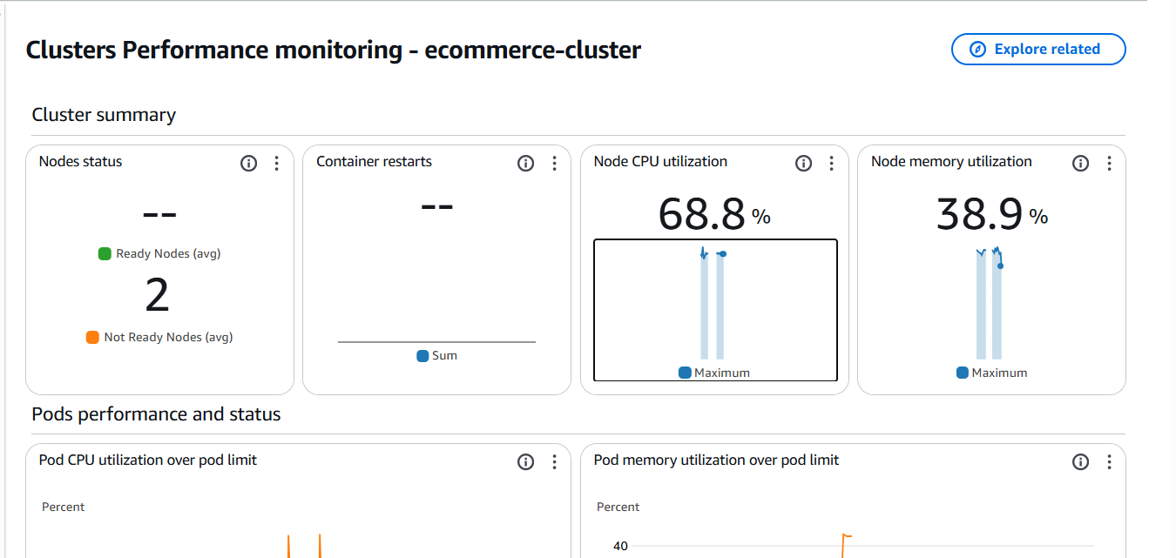

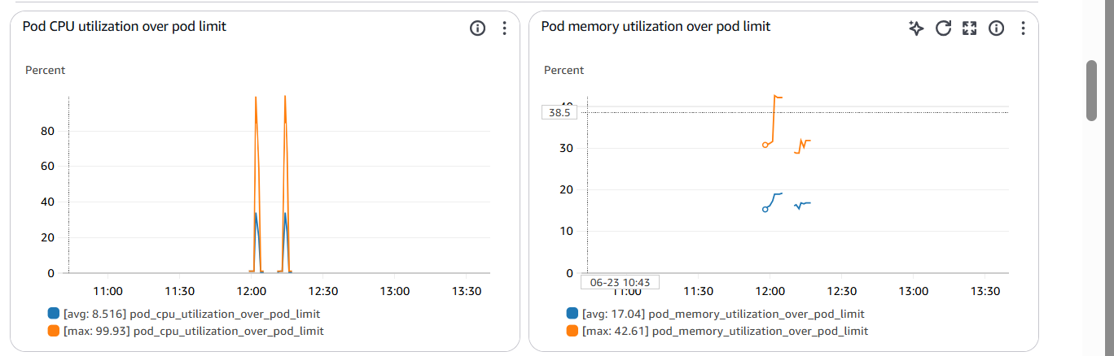

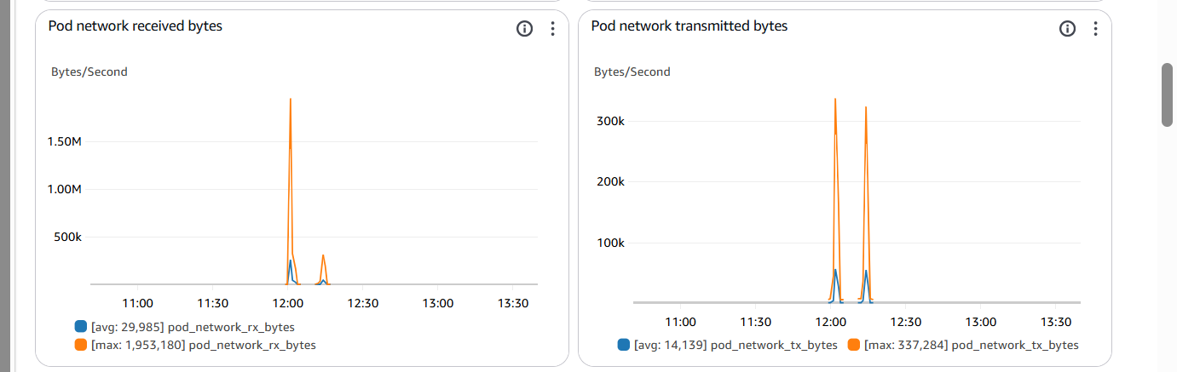

An SNS topic like eks-alerts was created to receive CloudWatch alarm notifications via email.

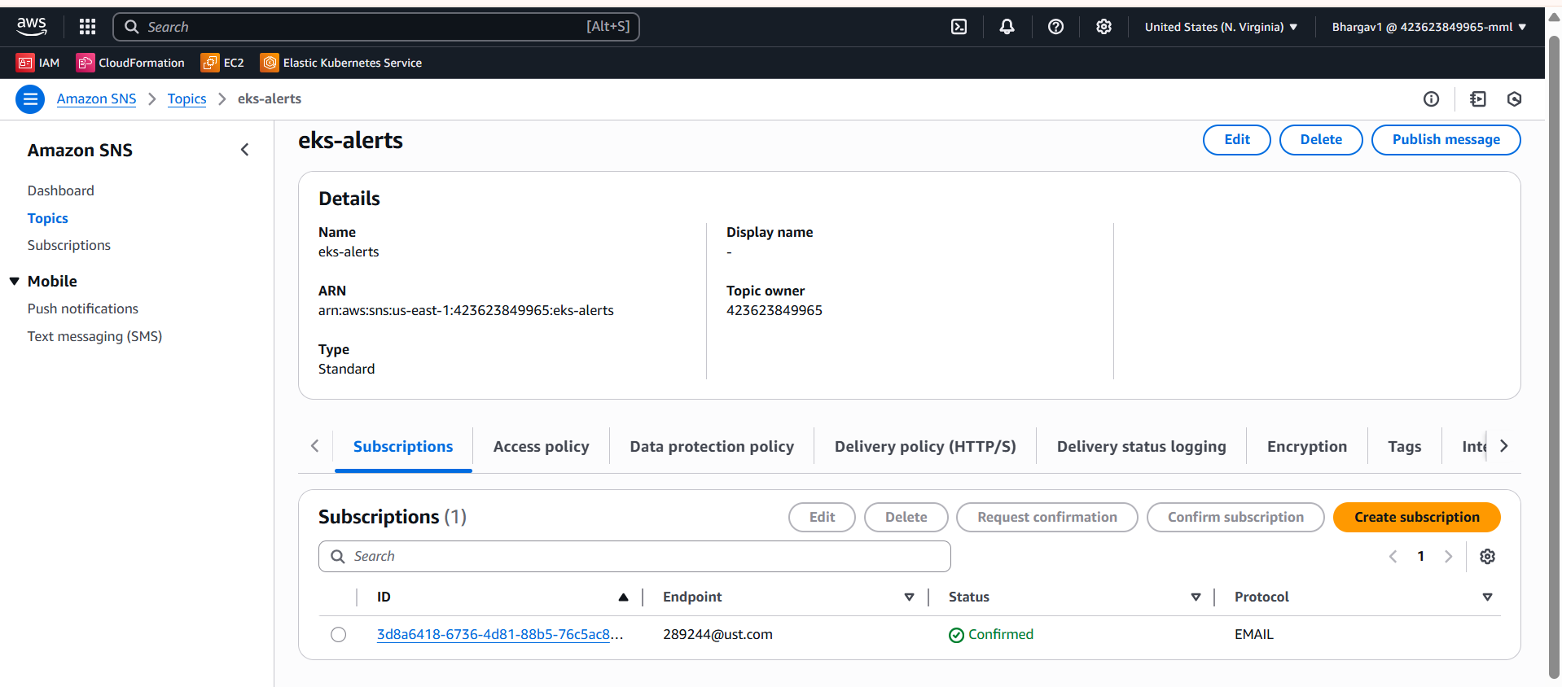

CloudWatch alarm is set to monitor CPU usage over 80% for two periods.

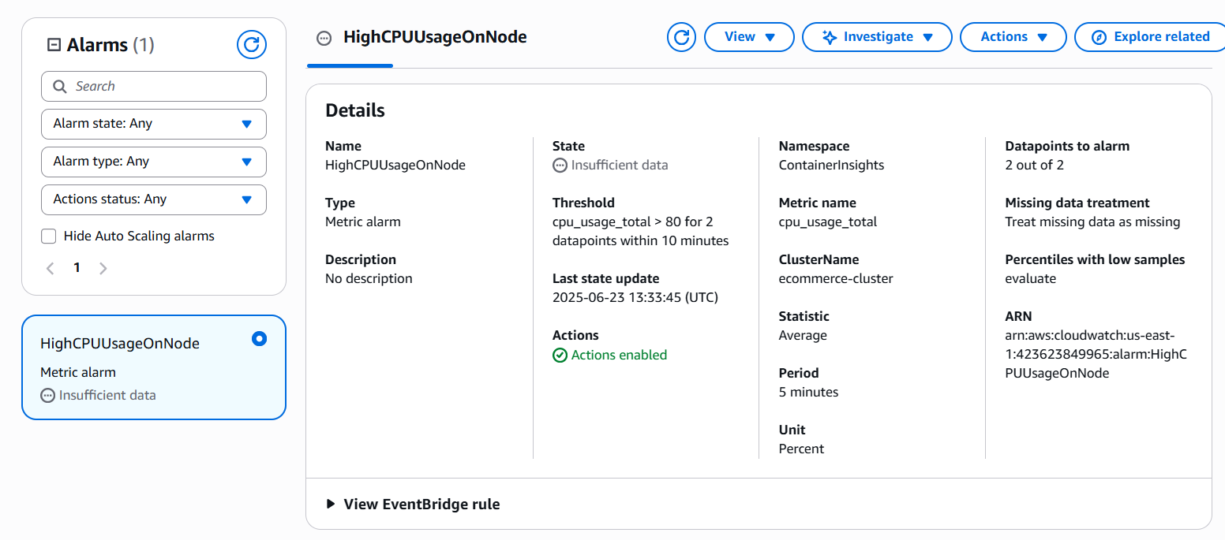

This alarm detects if any pod in the cluster restarts more than once in a 5-minute window, triggering an alert for investigation.

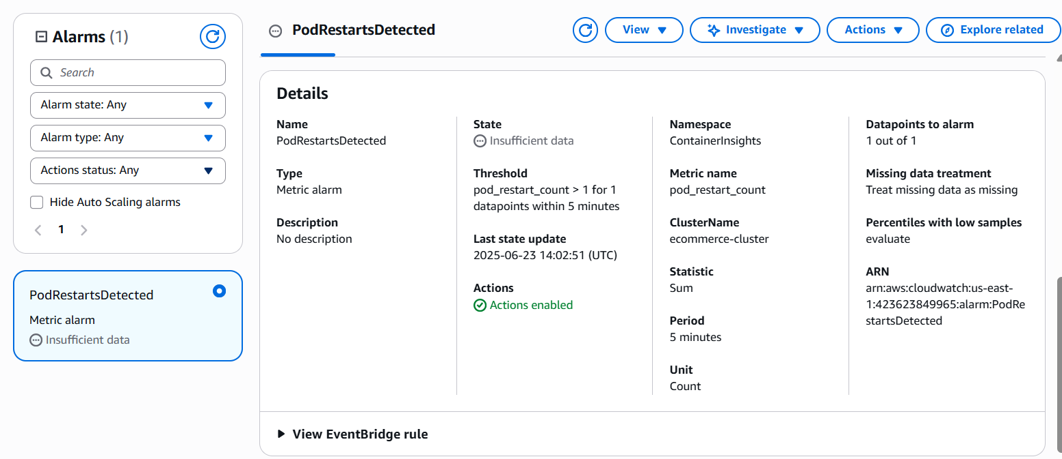

A CloudWatch alarm named HighMemoryUsageOnNode was configured to monitor memory usage of the EKS cluster. If memory exceeds 30% for two consecutive 5-minute periods, an email alert is triggered via the eks-alerts SNS topic.

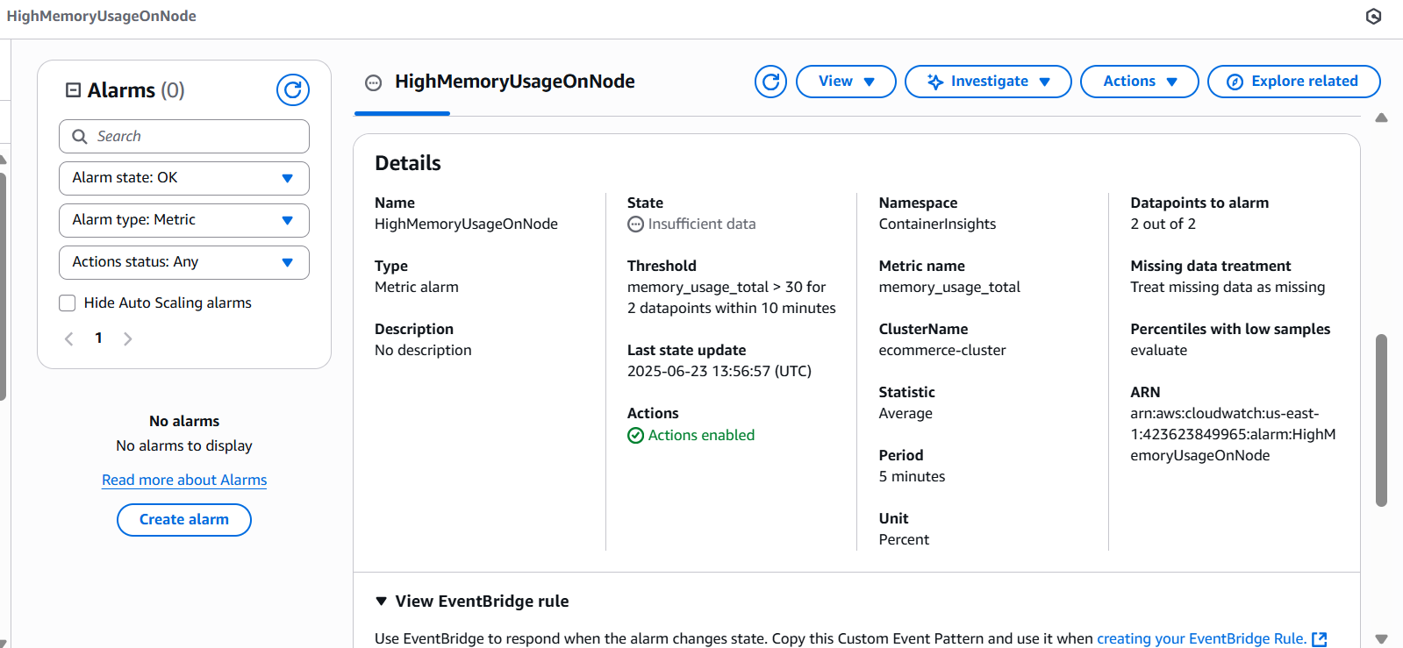

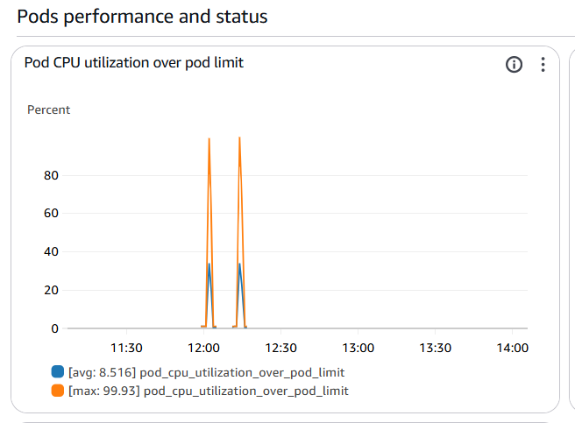

Testing for Alert Message

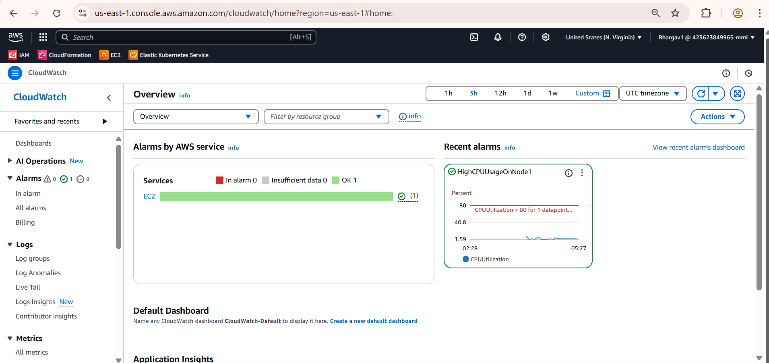

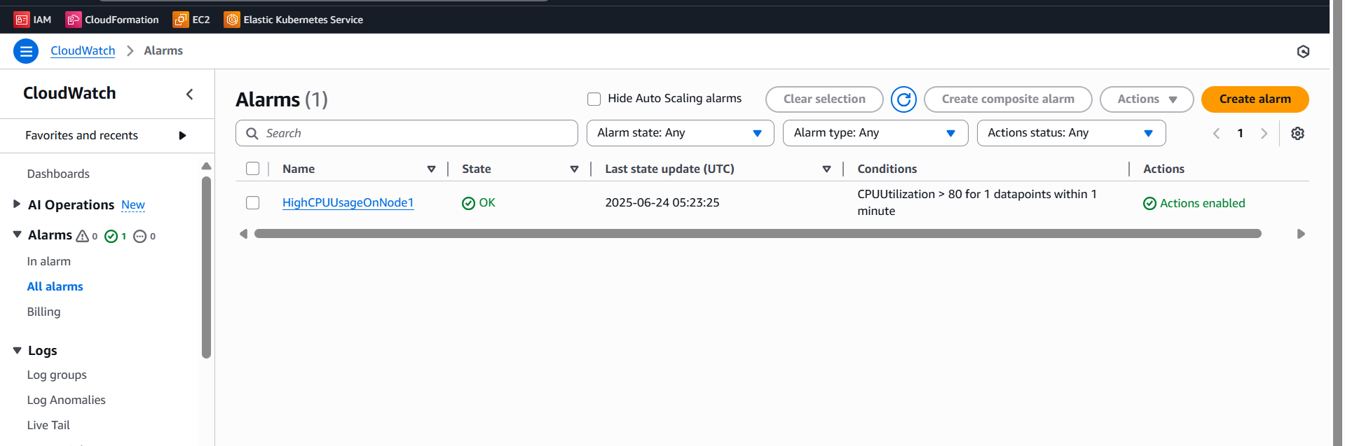

Here I Got Alert Message to my mail

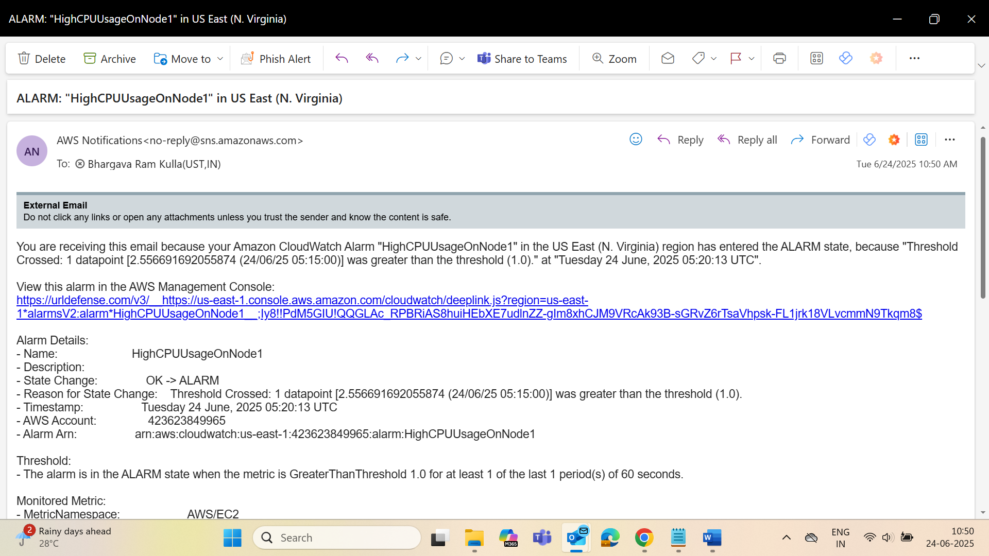

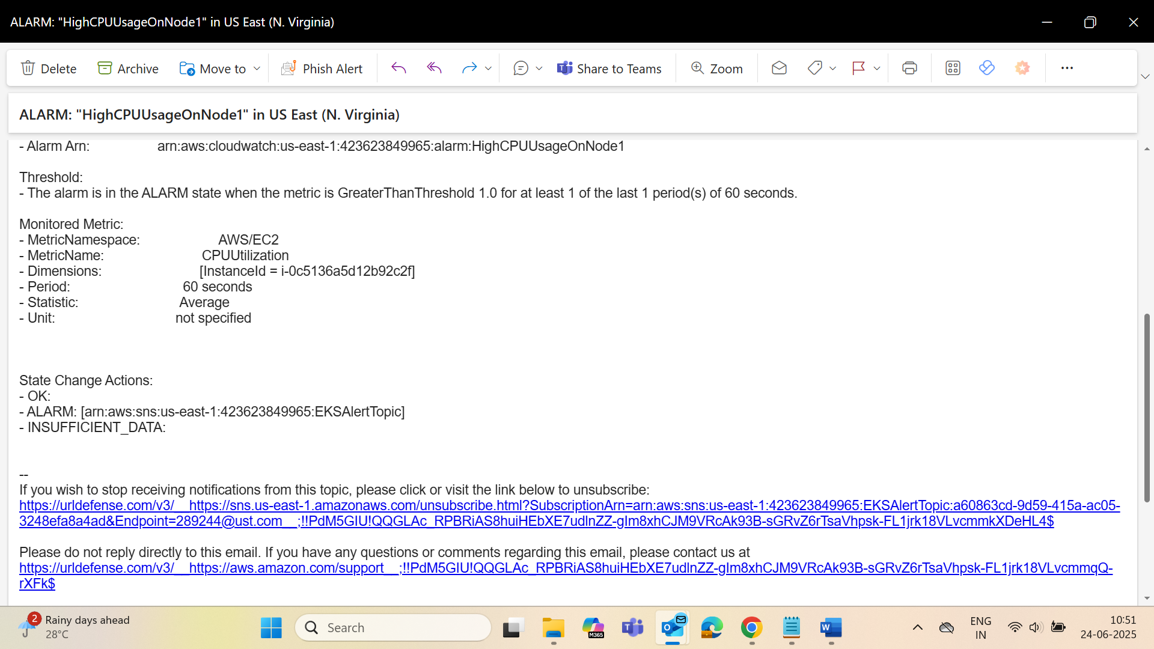

**SonarQube**

We use SonarQube here to automatically review and measure code quality and security

* Code quality is good
* There are no bugs, security issues, or duplication
* The Quality Gate has passed

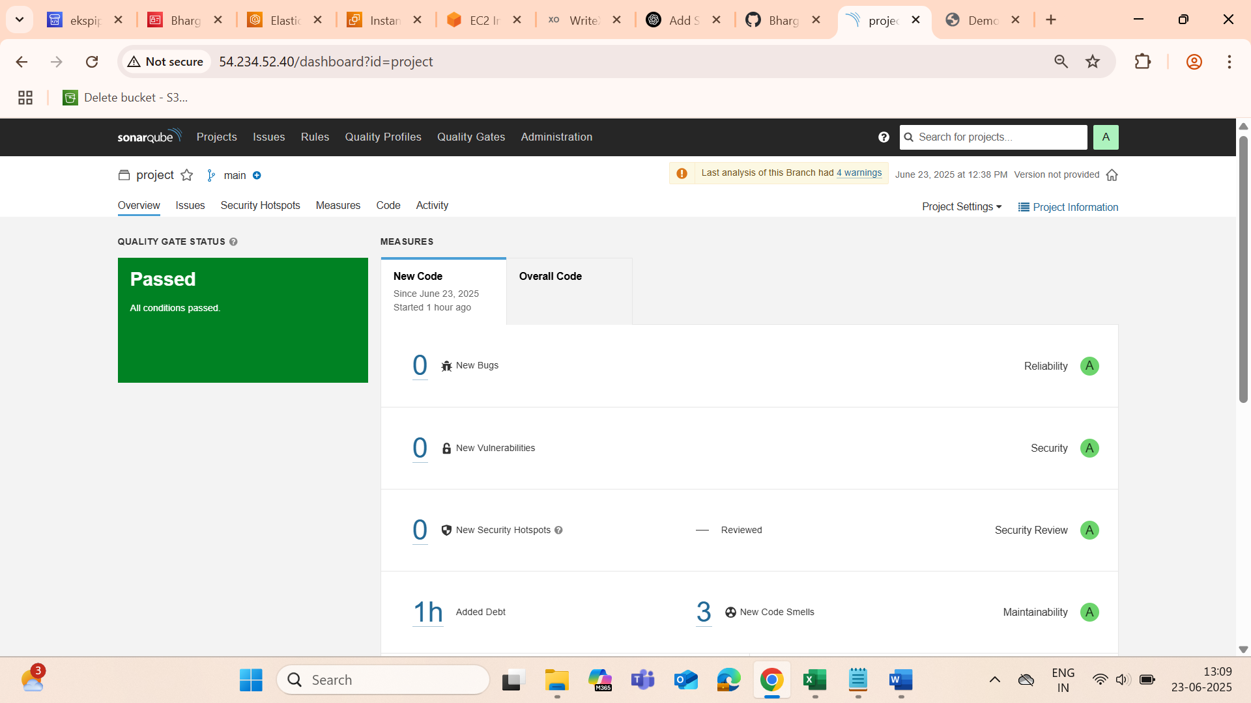

Next we will check whether our all pods are running or not

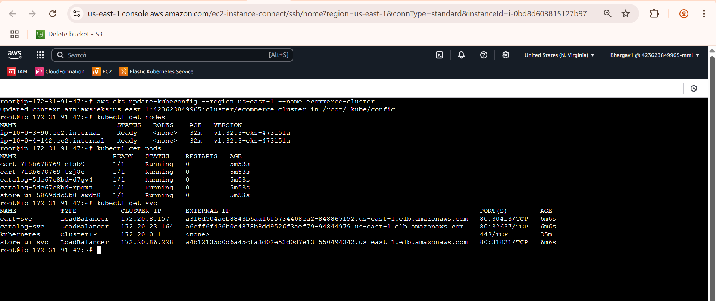

**Pipeline Trigger Using Lambda, SNS and EventBridge**

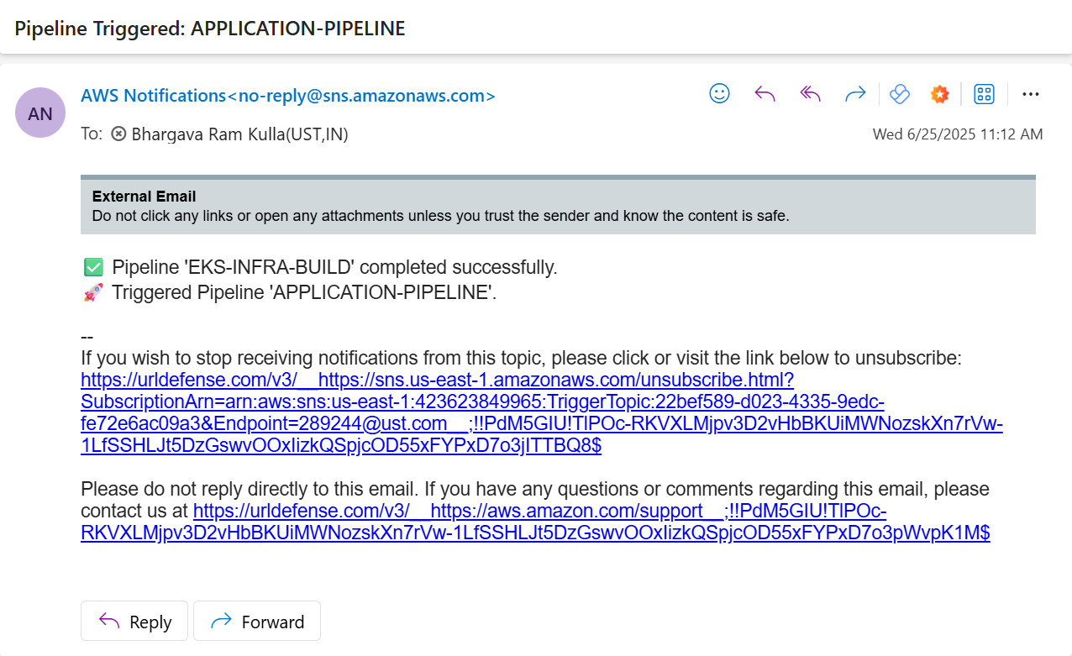

**Route53**

* Bought a domain bhargavkulla.com
* Set up a Route 53 health check to monitor the health of the primary endpoint
* Configured DNS Record with Failover Routing
* Then accessed the website with the domain name bhargavkulla.com

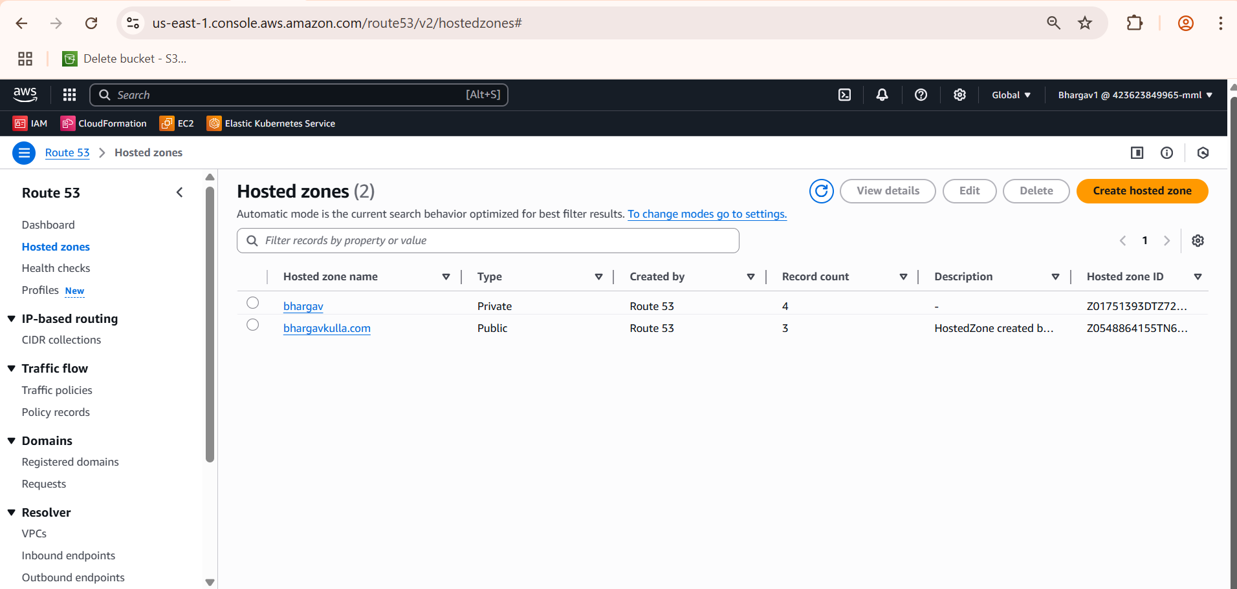

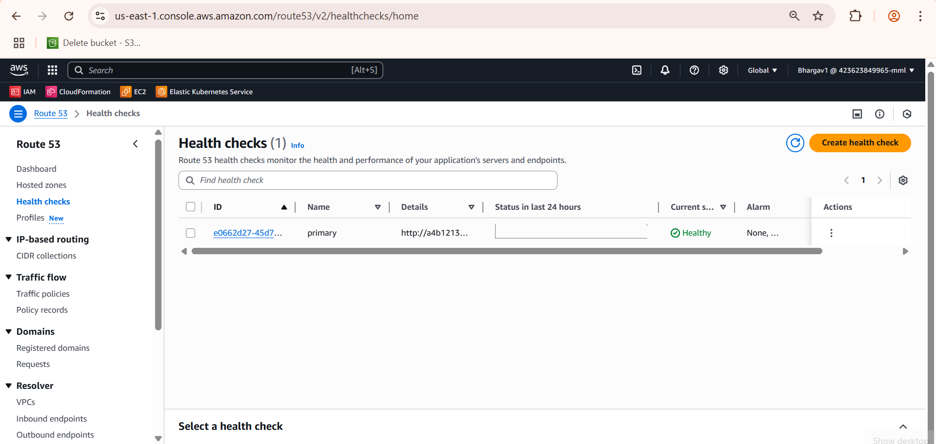



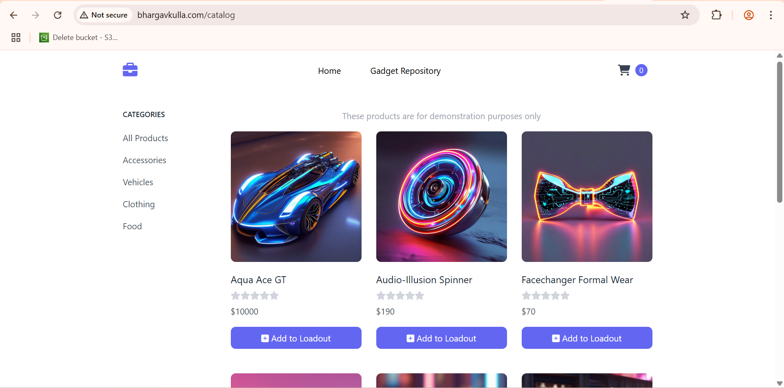

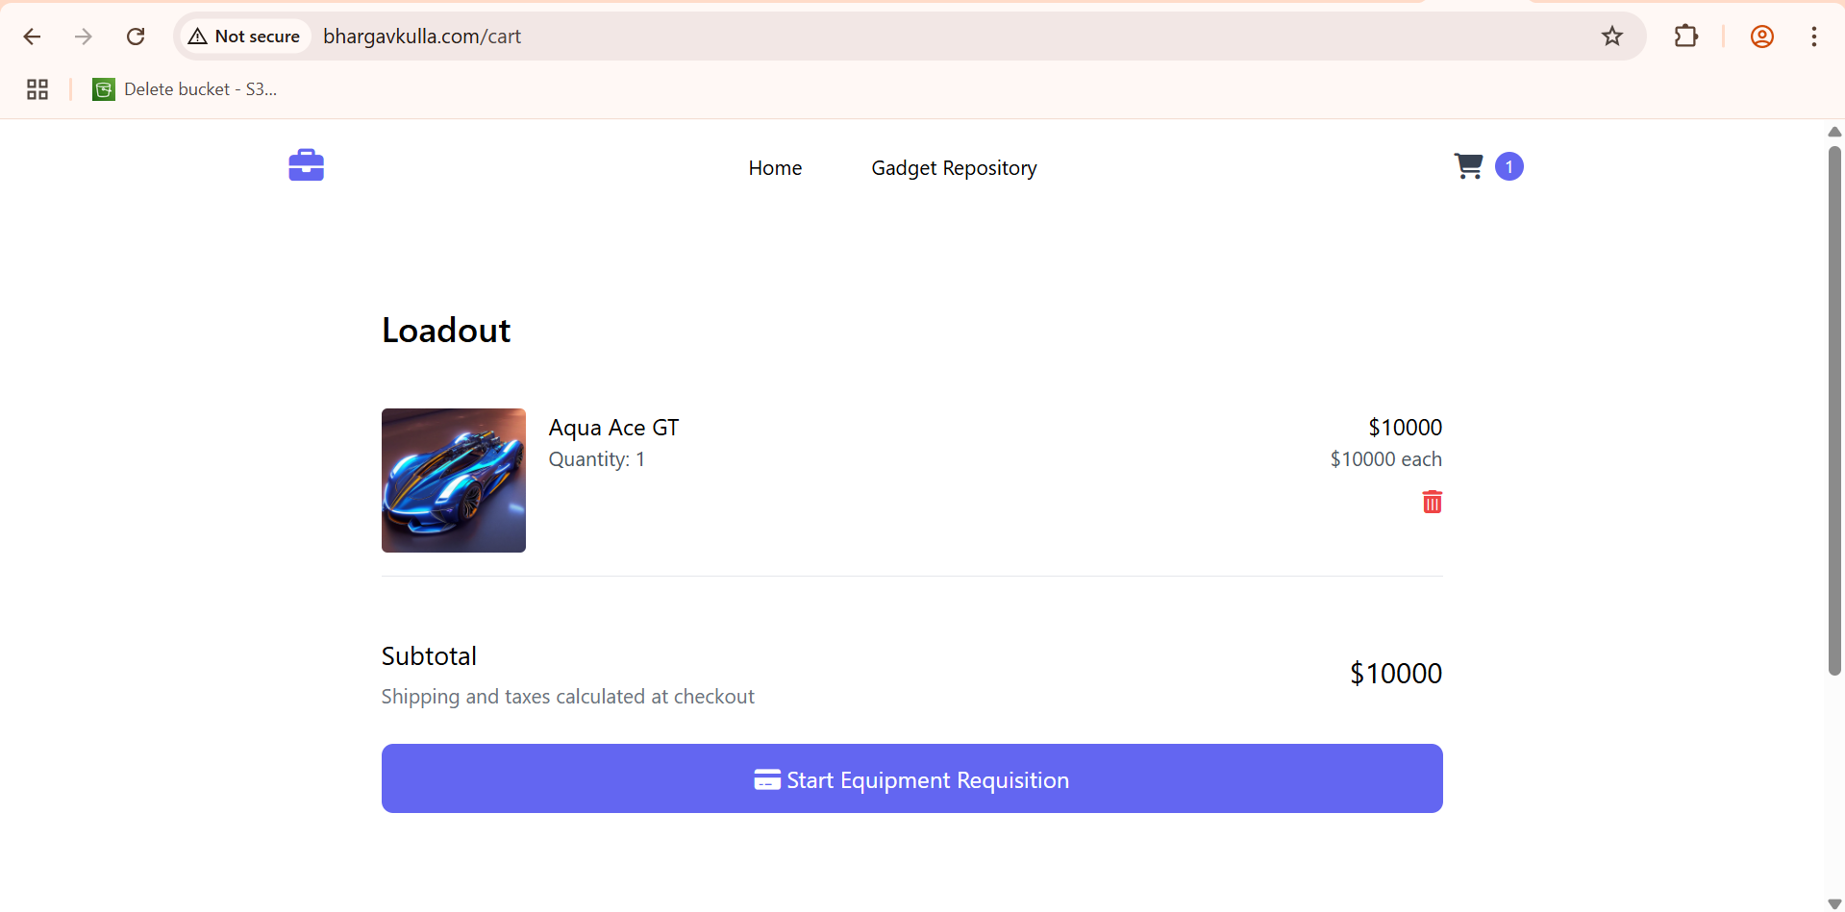

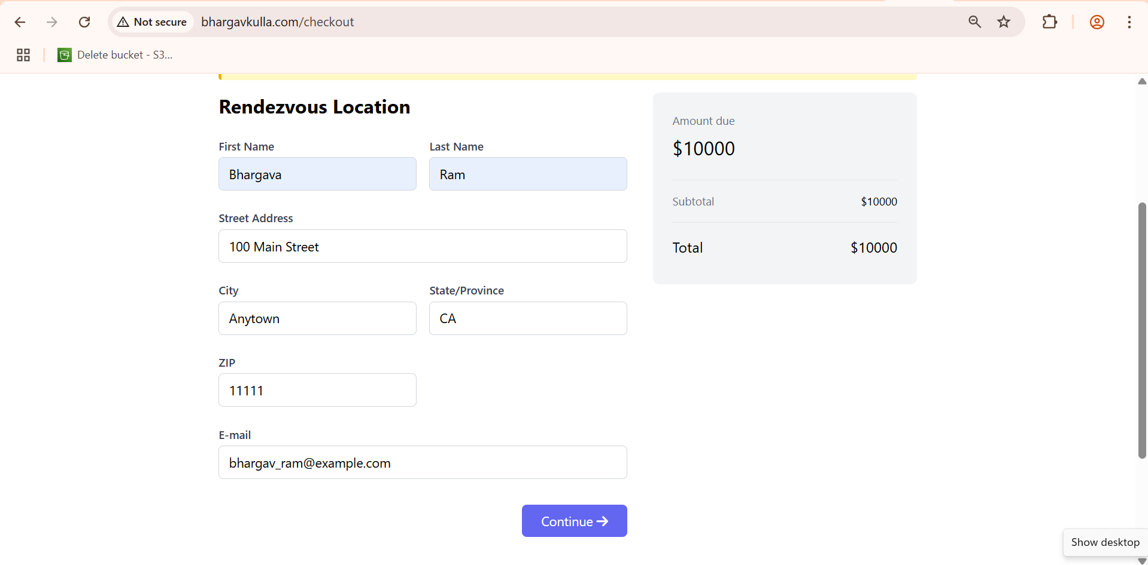

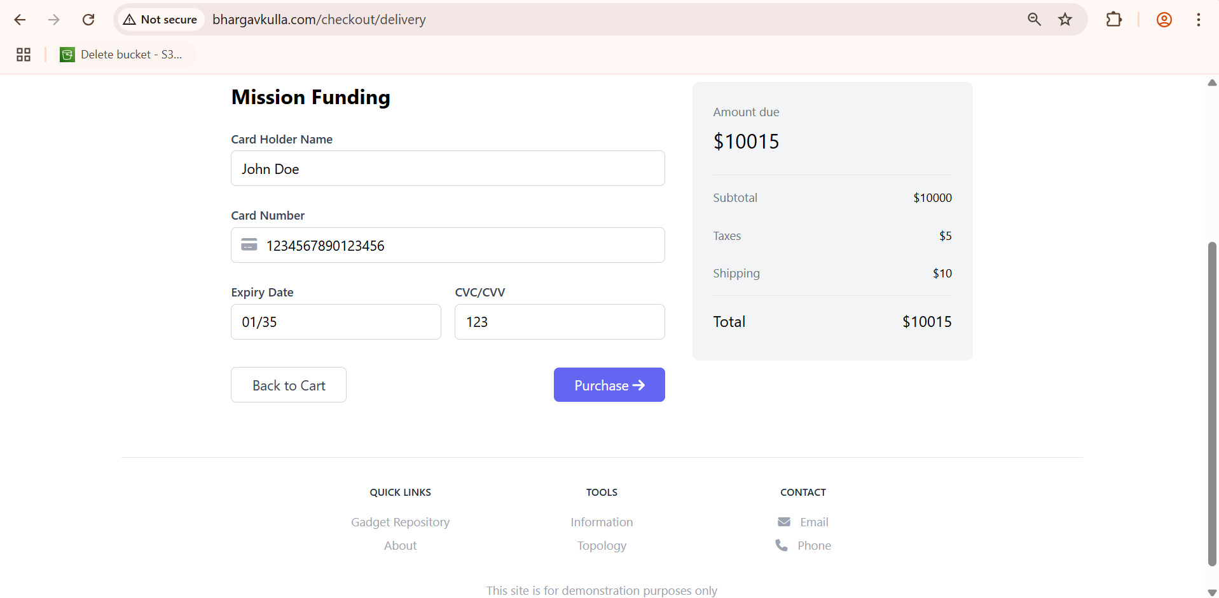

**If Pipeline Fails?**

* We will get mail that Pipeline Failed
* We will do this using Event Bridge
* For that First we should create Topic then add subscription
* Then Create Lamba
* Then Go to Event Bride and select CodePipeline(Failure)

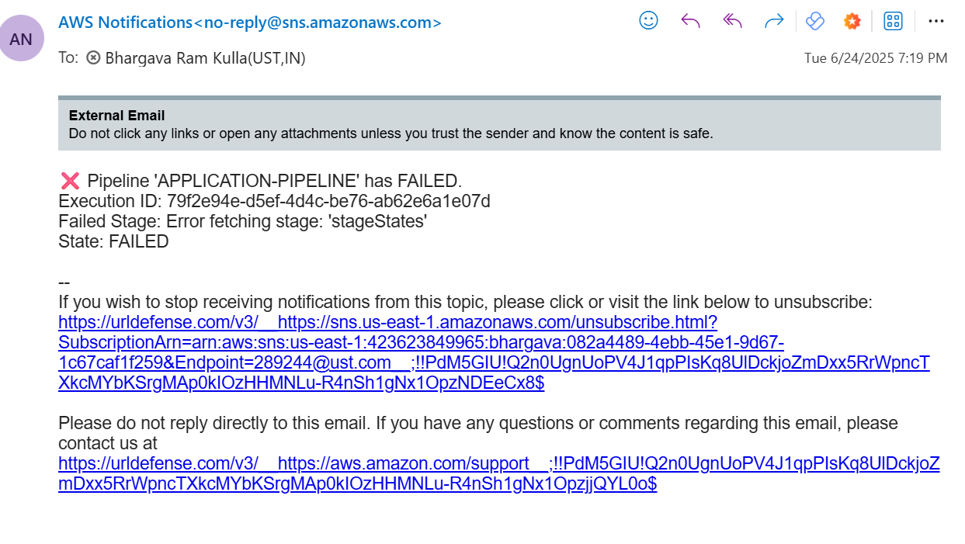

**REGION 2 (us-west-1)**Codecommit

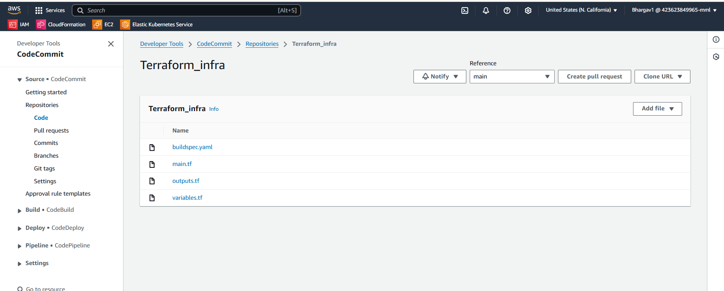

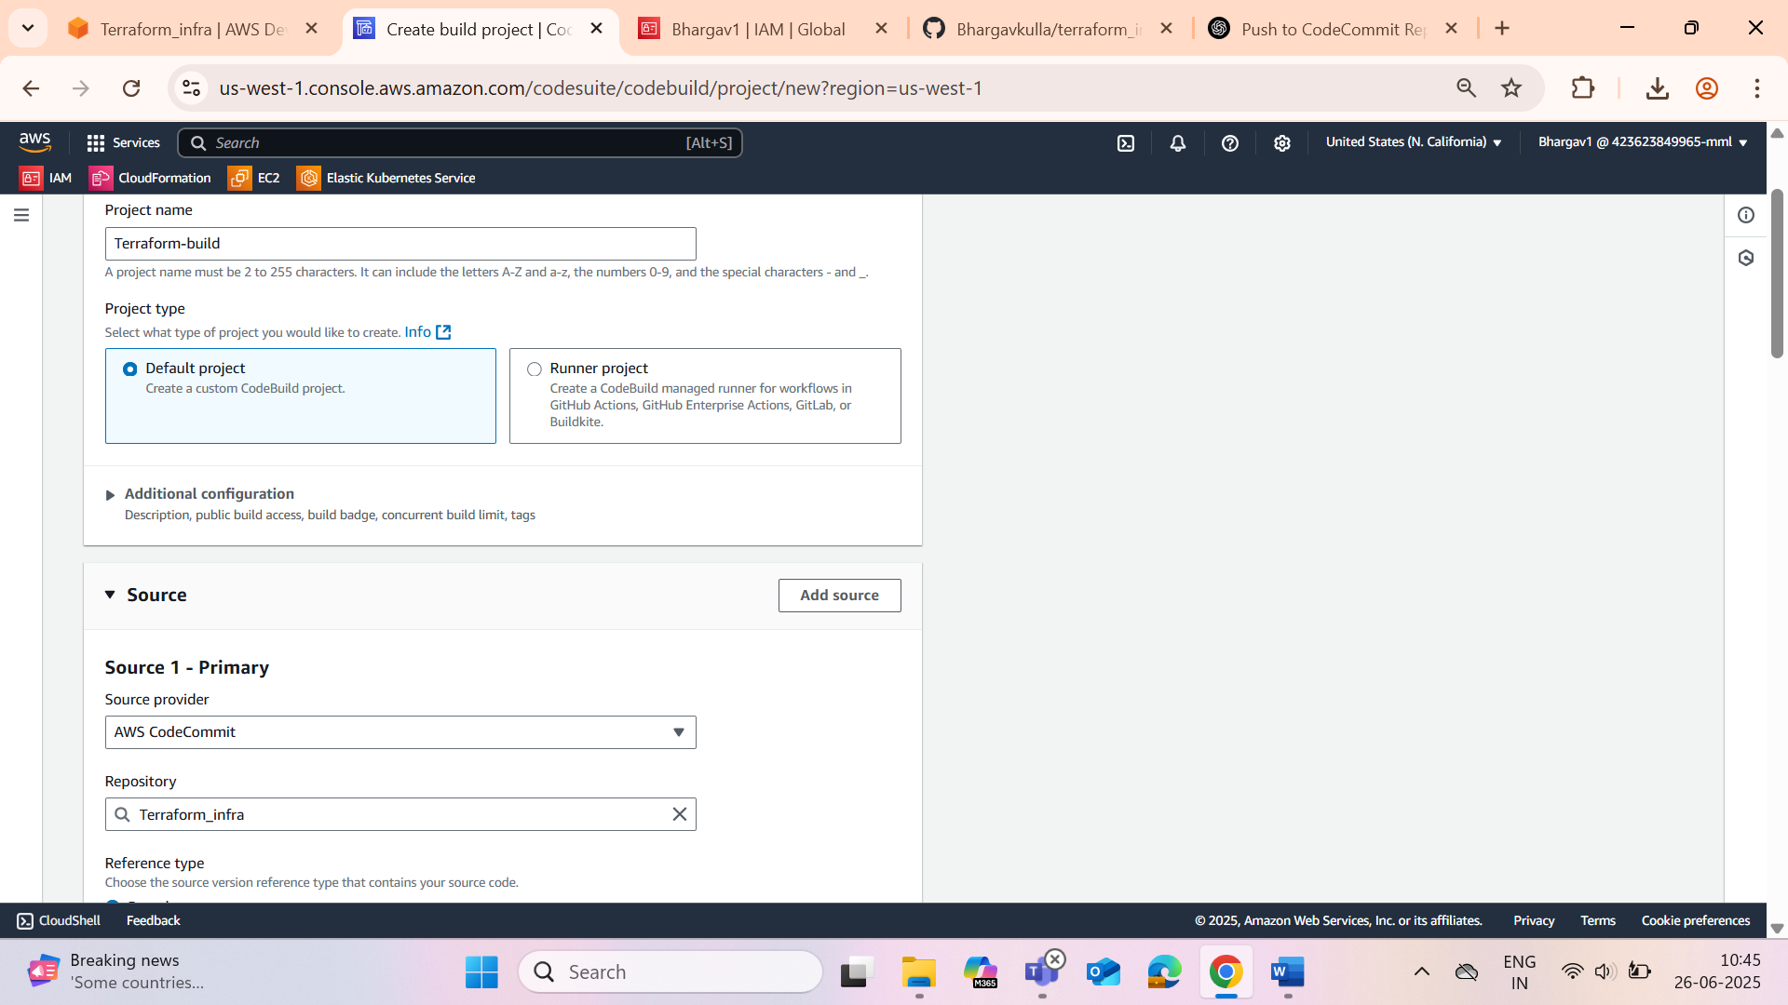

CodeBuild using CodeCommit

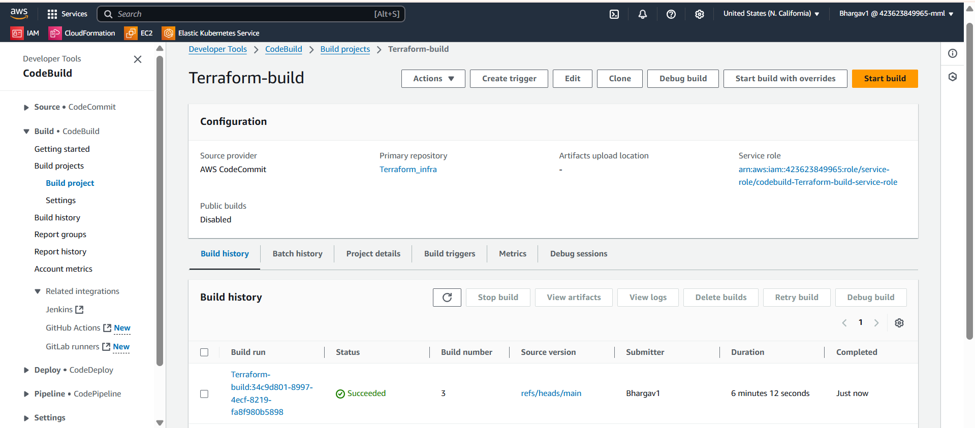

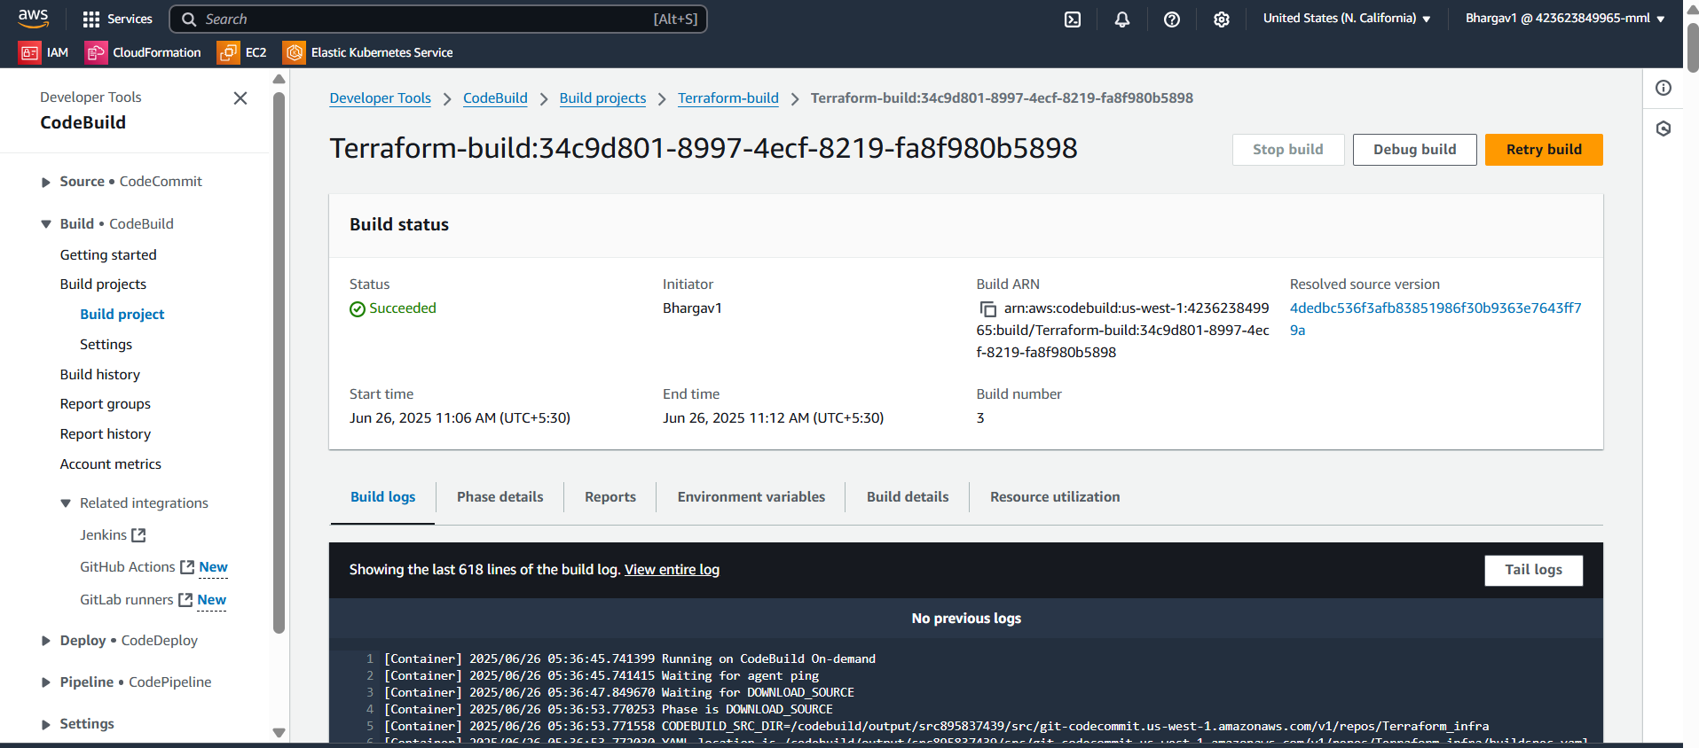

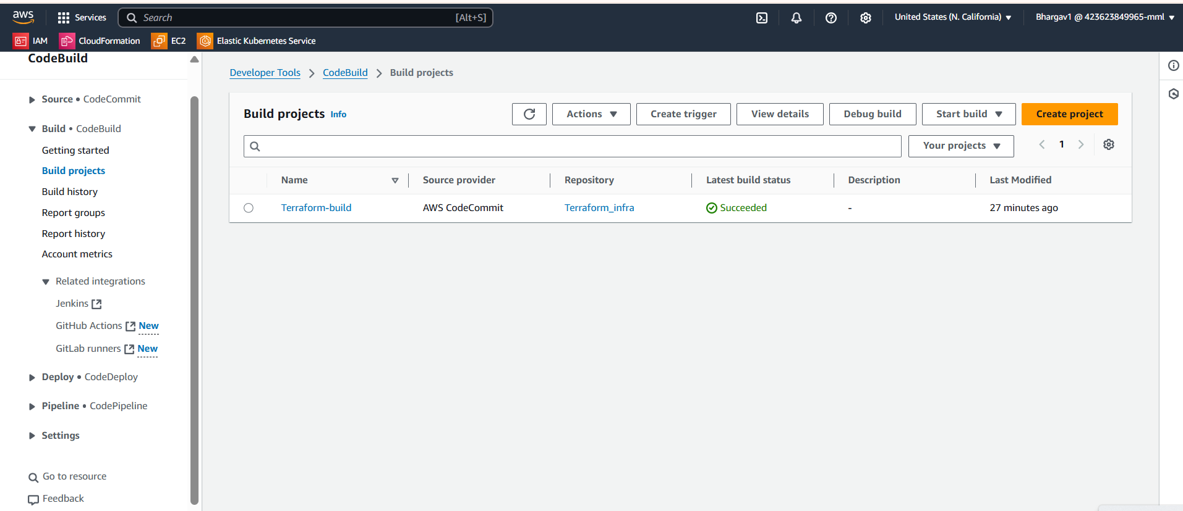

Created ECR’s

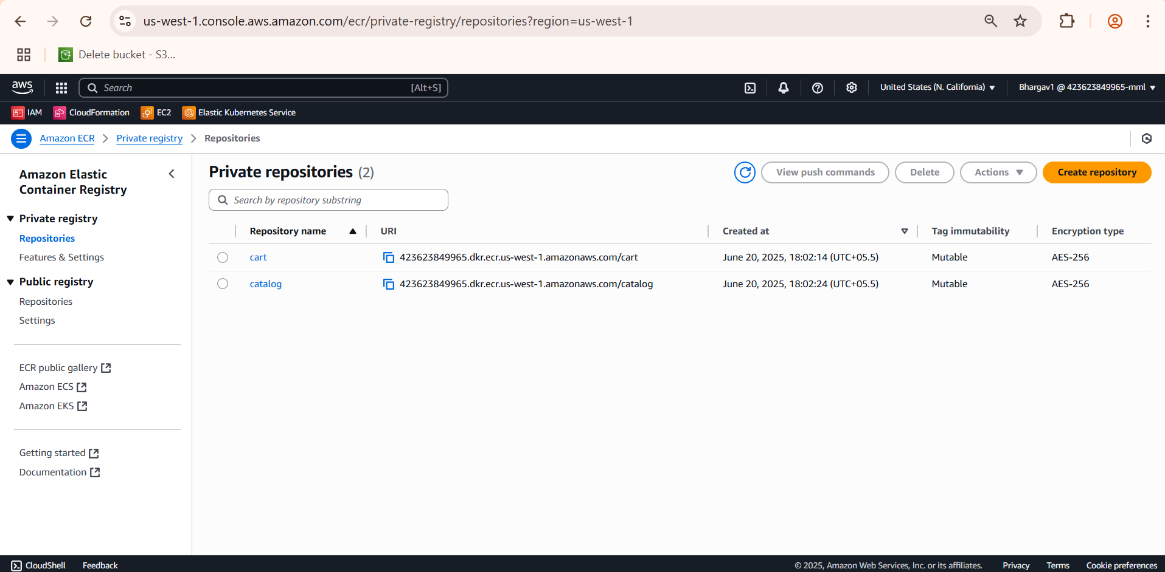

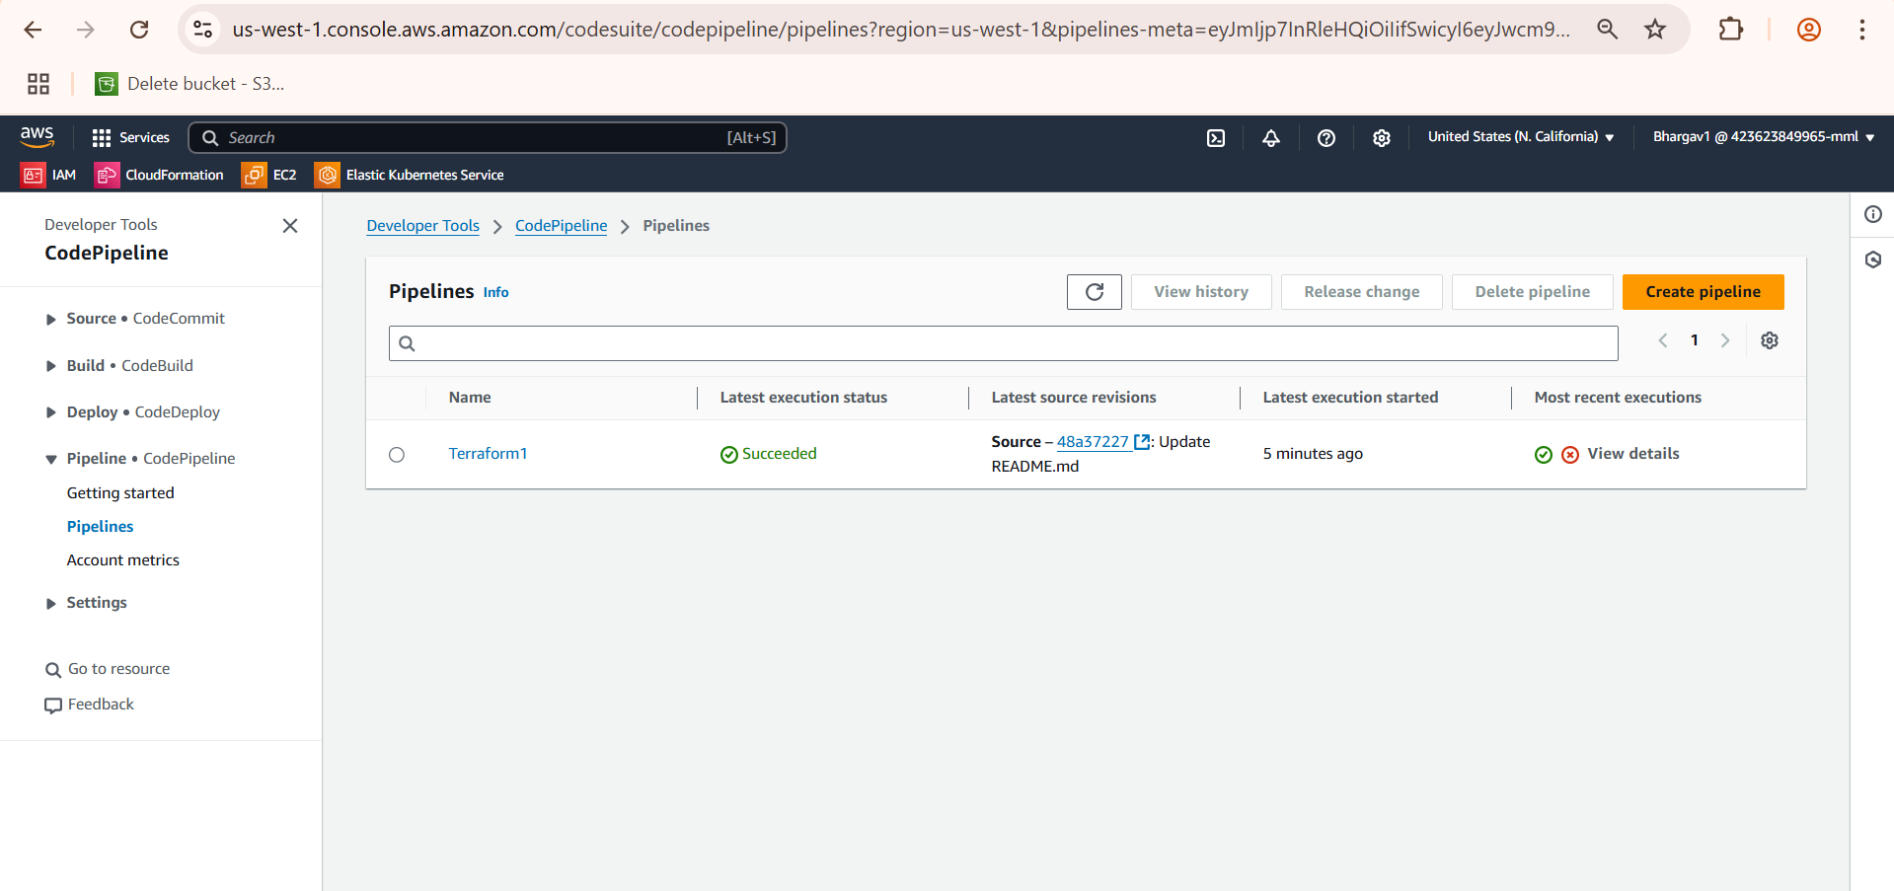

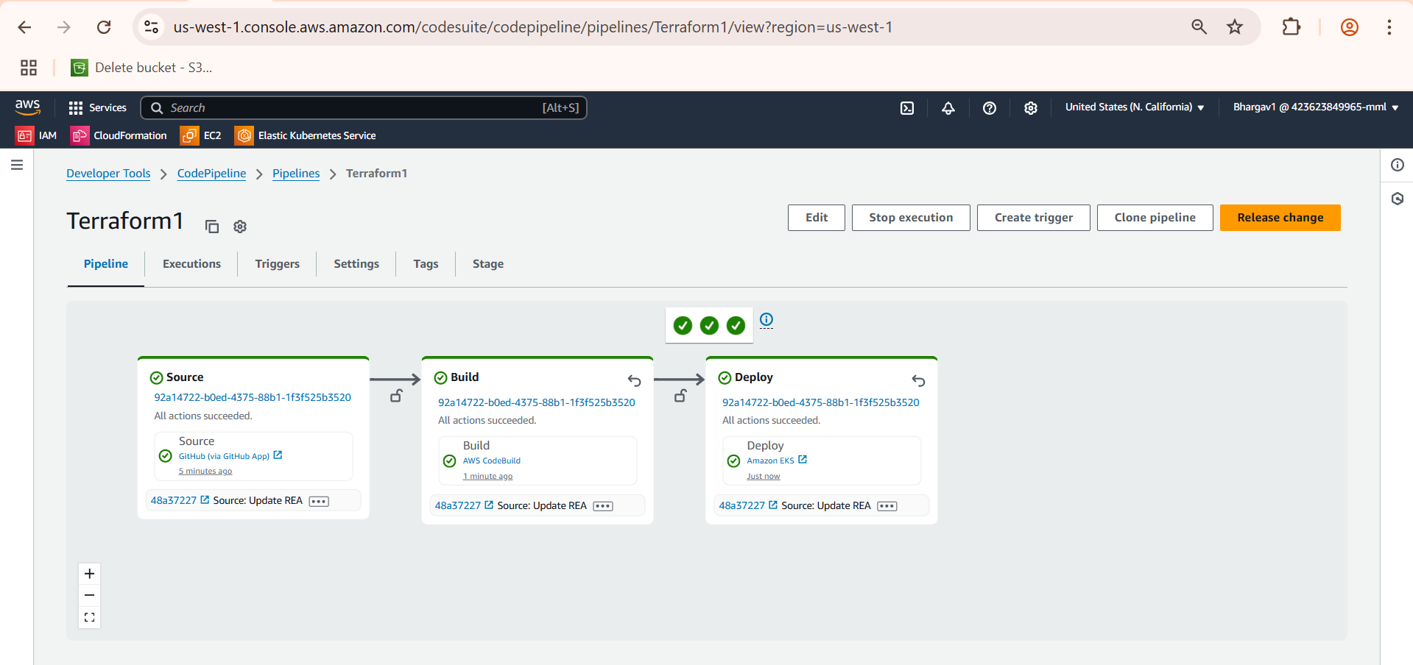

Check all pods are running or not then check service

**aws eks update-kubeconfig --region us-west-1 --name ecommerce-cluster**

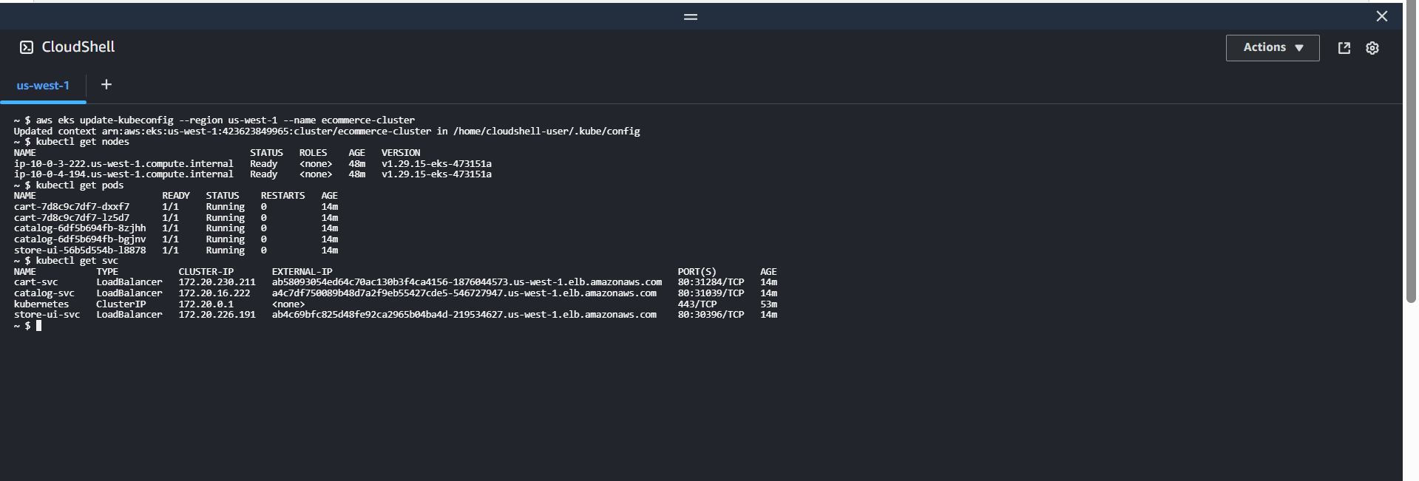

Route53

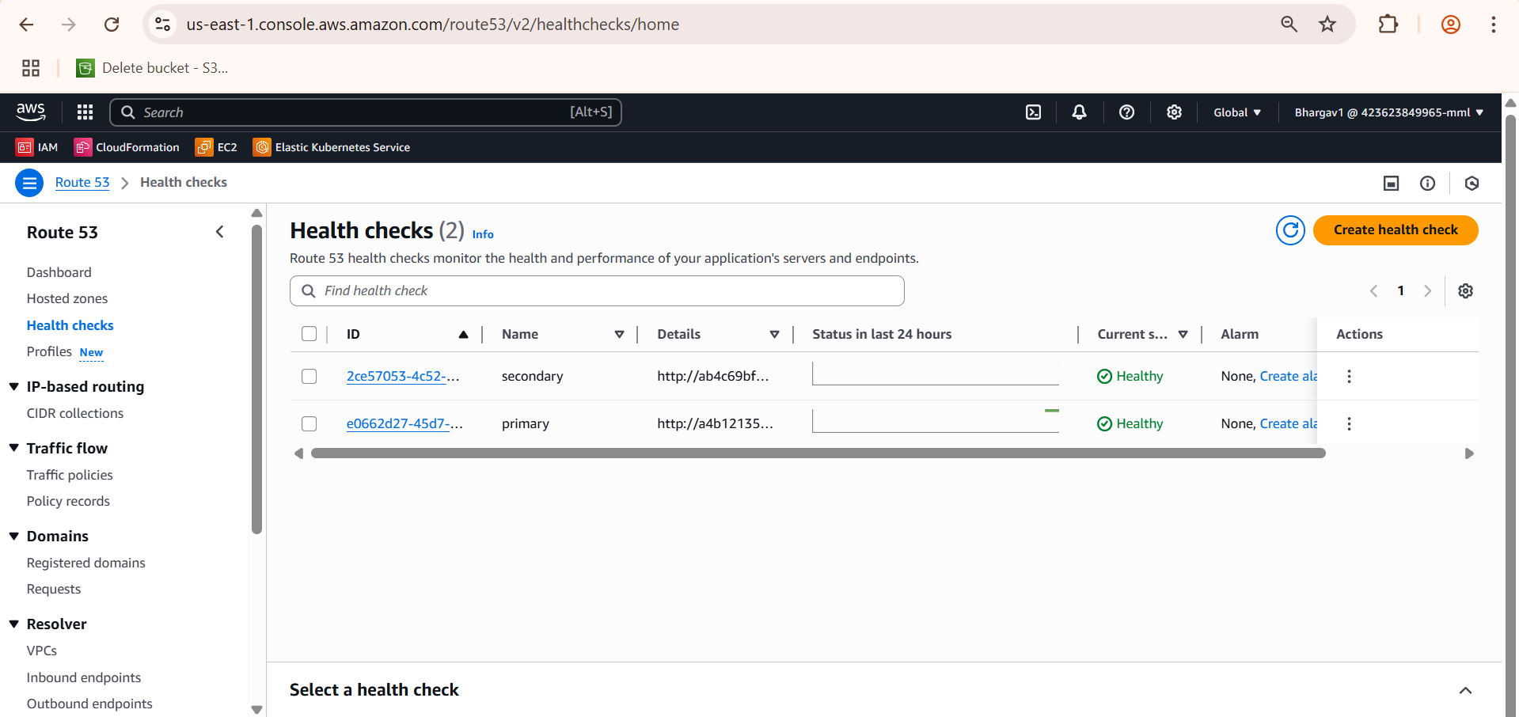

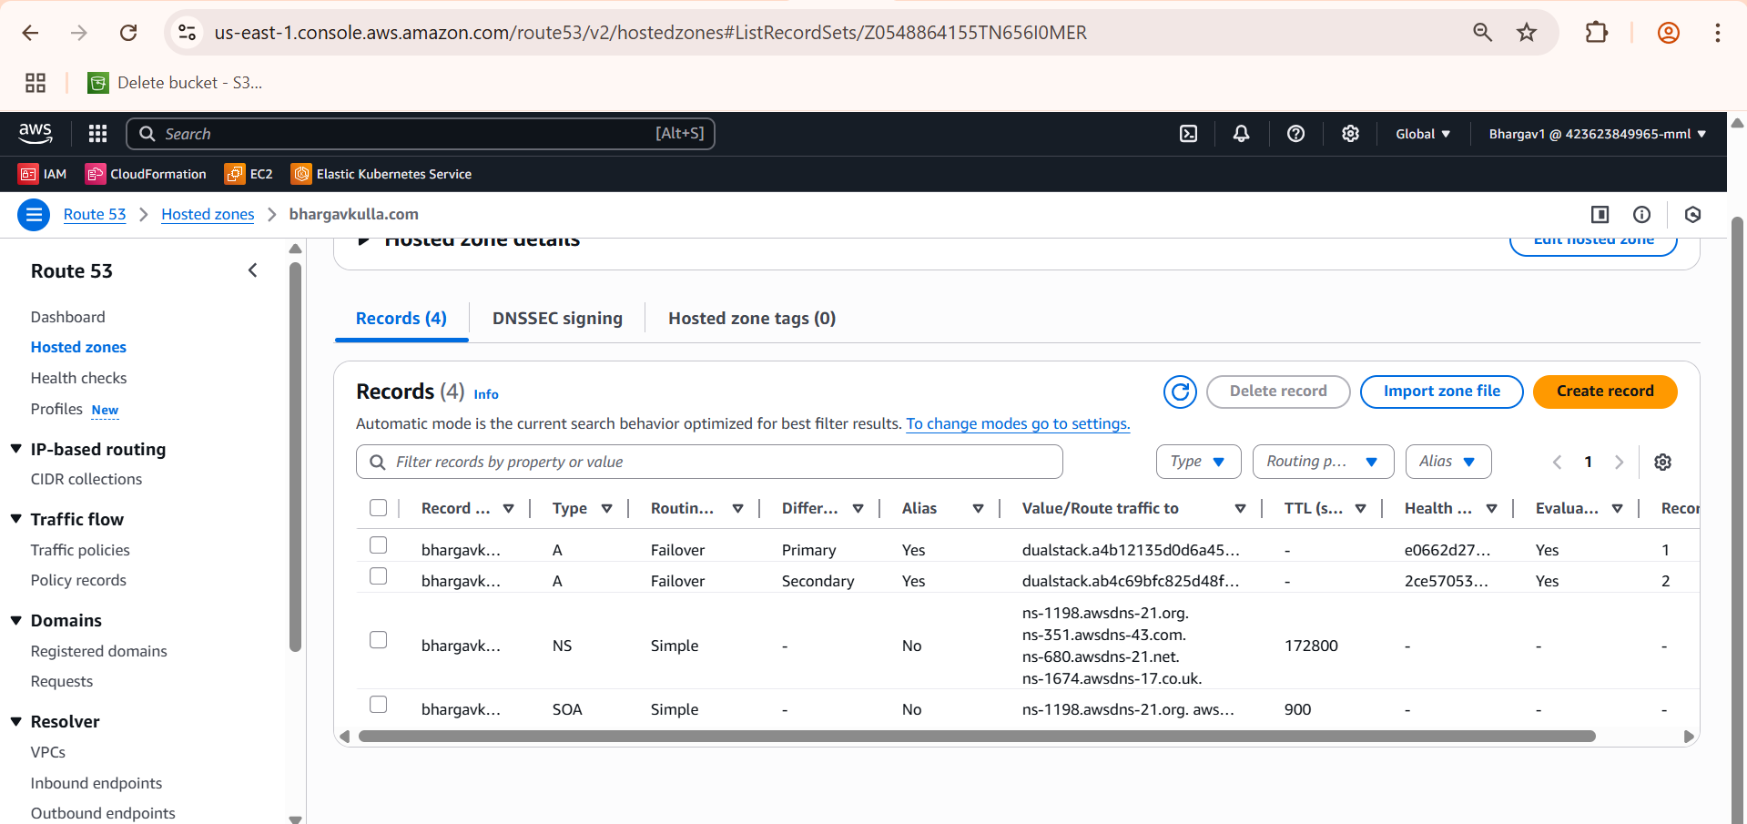

Website accessed with bhargavkulla.com



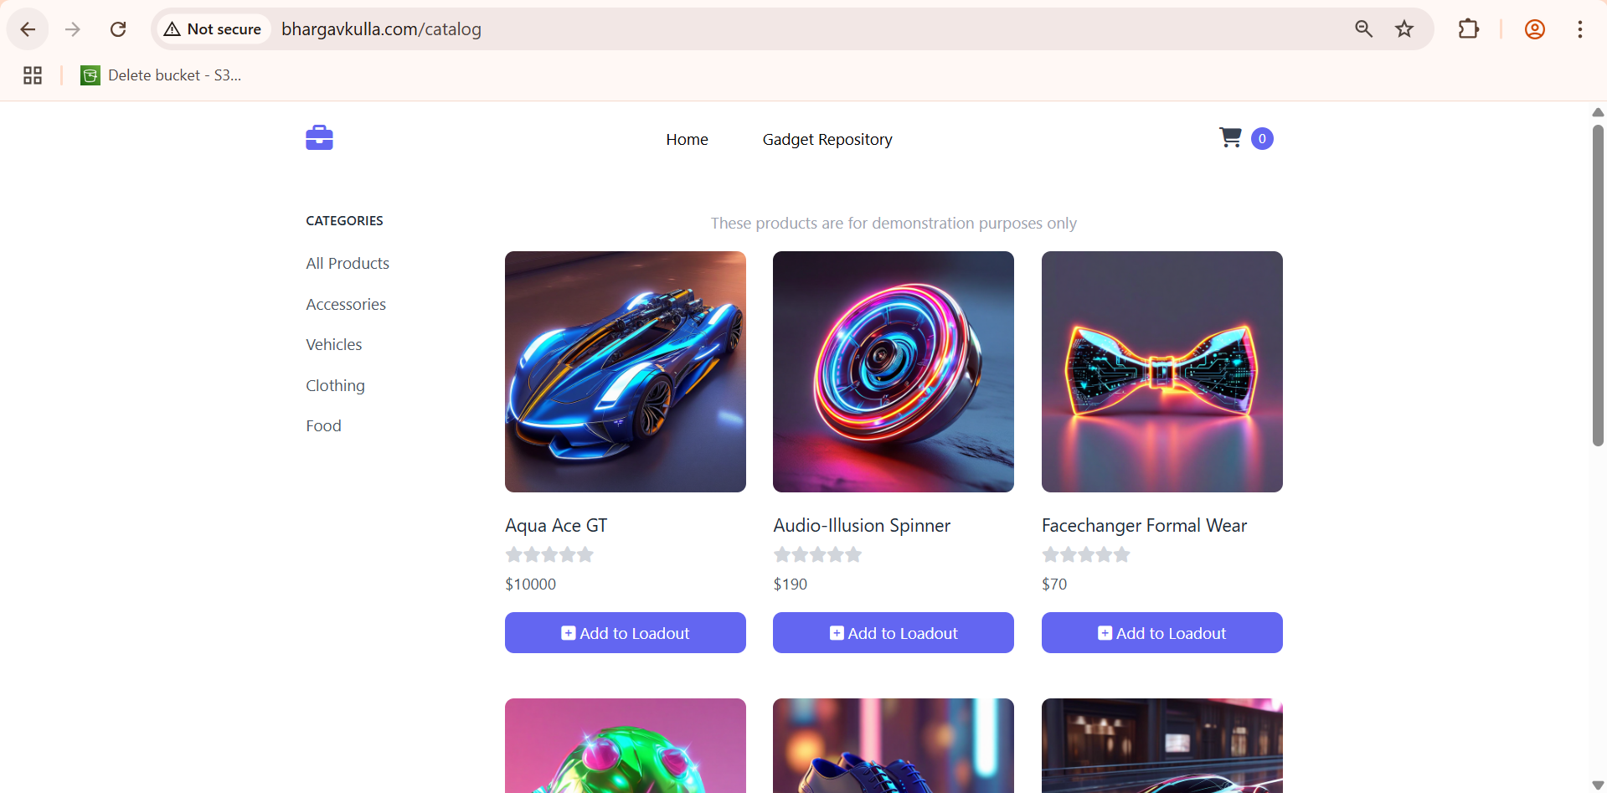

**Prometheus and Grafana**

